second titration day  CλeMis+ry: http://genest.weebly.com  Stop in for help every day at lunch and Tues, &Thurs after school!  After-hours question? Email me at home: eagenest@madison.k12.wi.us | i | Name_________  Period________

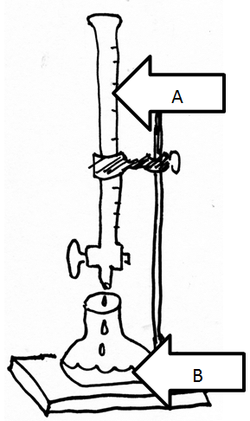 | - If you begin the titration and you are using phenolphthalein, where do you put it? ( A / B )  - If you start out with NaOH in the burette at A and have HCl in the flask at B, the color of the phenolphthalein will be ( colorless / pink ) at the beginning of the titration and (colorless / pink ) at the end of the titration.  - A student put NaOH in the burette, HCl in the flask, did a titration and recorded the following:  [NaOH] = 0.449M  volume of HCl in the flask: 44 mL  initial reading of the burette: 45.00 mL  final reading of the burette: 23.76 mL  Calculate the [HCl]  - Calculate the pH of the HCl

- Which of the following solutions is the most acidic?
a. [H⁺]= 1 x 10⁻¹⁴ c. [H⁺]= 1 x 10⁻⁷
b. [OH⁻] = 1 x 10⁻⁷ d. [OH⁻] = 1 x 10⁻⁹
- When tested, a solution turns red litmus to blue. This indicates that the solution contains more
  - more H+ ions than OH- ions
  - more H₃O+ ions than OH- ions
  - more OH- ions than H₃O+ ions
  - more H+ and OH- ions than H₂O molecules
- If an aqueous solution turns blue litmus red, which relationship exists between the hydronium ion and hydroxide ion?
  - [H₃O+] < [OH-]
  - [H₃O+] = [OH-]
  - [H₃O+] > [OH-]
  - Neither ion is present

From here down is Sort of a review of
Unit 9 (April 7 through april 24)

- 3 H2 + N2 ---> 2 NH3 + 92kJ
a) How many litres of hydrogen are required to produce 5.0 litres of NH3 at the same temperature and pressure? Assume STP conditions.

b) What amount of energy is released when 5.00 grams of NH3 are produced?

c) Given the reaction above, what mass of nitrogen is needed to produce 889.0 kJ of energy?

- 2 C10H22 + 31 O2 ---> 20 CO2 + 22 H2O + 13483kJ
a) What volume of CO2 is produced when 17.4 litres of oxygen is used? Assume STP conditions.

b) What amount of energy is released when 1.00 gram of C10H22 is burned?

- 4 NH3 + 5 O2 ---> 6 H2O + 4 NO + 905kJ

a) What mass of NO is produced when 2.0 moles of NH3 react?

b) What volume of NH3 is required to react with 3.00 litres of oxygen at STP?

c) What volume of gaseous water, at STP, is produced along with 2.83 litres of NO gas at STP?

d) How much energy is produced when 2.70 grams of NH₃ are burned?

