CλeMis+ry: http://genest.weebly.com  Our final is on Monday (7th_{Pd}) or Wednesday (6th Pd)  After-hours question? Email me at home: eagenest@madison.k12.wi.us | 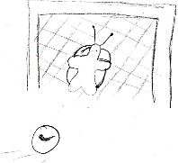 | Name_________  Period________

Go through the eight formulas below and circle any that have a metal with an unpredictable charge Then name each compound. You only use a Roman numeral if there is a metal with unpredictable charge.

- Na₂CO₃ _________________________
- VCO₃_________________________
- Fe(NO₃)₂_________________________
- (NH₄)₂CO₃_________________________
- Au(NO₃)₃_________________________
- Fe₃(PO₄)₂_________________________

- What’s the formula of each?

Copper (II) bromide __________________

Look at these naming examples to get you warmed up. Notice the asterisks match the footnoted rules
NaBr is named  sodium bromide * | Sc(OH)₃ is named s  candium hydroxide ** | V₂(SO₄)₃ is named  vanadium (III) sulfate ***

READ THE ASTERISKS AT THE PAGE BOTTOM. THEY ARE CLUES FOR NAMING THE FOLLOWING COMPOUNDS:

*** Ti(SO₄)₂ ______________________________________________
*** FePO₄ ______________________________________________
* NaBr ______________________________________________
** Ca(C₂H₃O₂)₂ ______________________________________________
* K₃N ______________________________________________
*** CuOH ______________________________________________
* Zn(NO₂)₂ ______________________________________________
V₂S₃ ______________________________________________
Ca₃P₂______________________________________________________________

Write the formula of each compound shown below
- sodium phosphate  - copper (II) nitrate  - copper (II) nitride | - magnesium nitrite  - tin(IV) oxide  - Aluminum Iodide

Instructions: Copy these six formulas into the appropriate two lists below.
N₂O₄ Al₂S₃
H₂O CO CuCO₃ C₂H₆

List each ionic formula then write a name : | List each molecular formula, then write a name using the mono/di/tri rules
1)  2) | 3)  4)  5) 6)
Instructions:
A) Circle any substance that is a molecular substance
B) Name each molecular substance you circled USING mono, di. tri RULES.
C) Now go back and name each ionic substance using NO MONO DI TRI –

- CBr4

- Hg2O

- NH3

- CsBr

- AgF
- SnI2

- N2O

- GeH4

- N2Br4
- P2S5

- SeO2

- HgS

- CuI

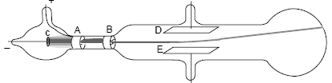
- What did JJ Thomson conclude was shooting in a line from left to right in this drawing?

It’s -important for us to know what the evidence is for the models of the atom this year.
Look at your notes from today, especially NOTE THREE. List an Observation that supports the following claims:
- Thomson claimed the stream he saw in his tube was made by particles; it was not ‘light’. _____________________________________________________________________________
- Thomson claimed the charge of each particle was negative _____________________________________________________________________________
- Thomson claimed that the cathode ray particles are contained in ALL matter. All atoms contain these negative particles. _____________________________________________________________________________

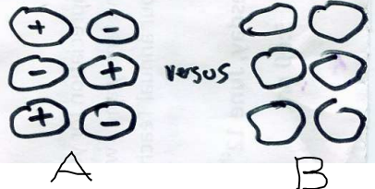
Mark yes or no for each statement below about the particles of matter shown here

- _________ If dissolved in water, Substance B would probably conduct electricity
- _________ Substance B will melt at a lower temperature than Substance A
- _________ The one most likely to be a molecular substance is Substance A

- Which of the following substances would you expect to conduct electricity?
a. bleach (a solution of sodium hypochlorite, NaOCl, in water)
b. dry baking soda (NaHCO₃)
c. rubbing alcohol (C₃H₈O)
d. sugar (C₁₂H₂₂O₁₁) dissolved in water

D) For each molecule below, write the formula and the name

- Below left is group of neutral atoms of paper. At the right, draw electrons as dots to sketch how you imagine the electrons would be arranged if a (+) tape were placed to the right of the sample of paper .
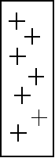

- When you ripped the tapes apart in the Sticky Tape Lab, the two pieces of tape were then attracted to each other. An hypothesis was proposed to account for this observation. Which of the following features of the hypothesis is NOT supported by this observation alone?
a. Some charged particle was transferred between atoms of the two tapes.
b. Atoms contain smaller particles that carry an electric charge.
c. The smaller, charged particle in the atom is negatively charged.
d. The smaller, charged particle in the atom is mobile.

- Which substance below is most likely to conduct electricity?
a. bleach (a solution of sodium hypochlorite, NaOCl, in water)
b. dry baking soda (NaHCO₃)
c. rubbing alcohol (C₃H₈O)
d. sugar (C₁₂H₂₂O₁₁) dissolved in water

This is a pretty good drawing of what Thomson thought a Plum Pudding NEUTRAL hydrogen atom looked like. It shows a positive circle with one electron in it. Refer to it when answering the five questions below

one hydrogen atom | one hydrogen atom | 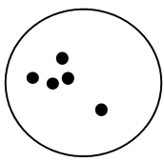  one hydrogen atom | one hydrogen atom | one hydrogen atom
- The charge of the atom in this box is  - positive  - neutral  - negative | - The charge of the thing in this box is  - positive  - neutral  - negative | - This is (choose one)  - an anion  - neutral  - a cation | - This is (choose one)  - an anion  - neutral  - a cation | - This is (choose one)  - an anion  - neutral  - a cation

*This has one metal and one nonmetal element. name it ELEMENT + ELEMENT + IDE
** This has three or more elements. You MUST use the polyatomic names from the back of your periodic table handout
*** This has a metal element with unpredictable charge, from the middle of the periodic table. You must assign a Roman Numeral. Don't be goofy: Roman Numerals DON'T tell how many atoms, they tell the "plus charge" of a single atom Example, in TiO₂, the name is Titanium(IV) oxide. The "IV" means there is a plus four charge on the metal atom.

