CλeMis+ry: http://genest.weebly.com  ---- Mr Genest will not be here after school on Wednesday -----  Your cheat sheet is a way to trick yourself into organizing your reviewing of your notes. | 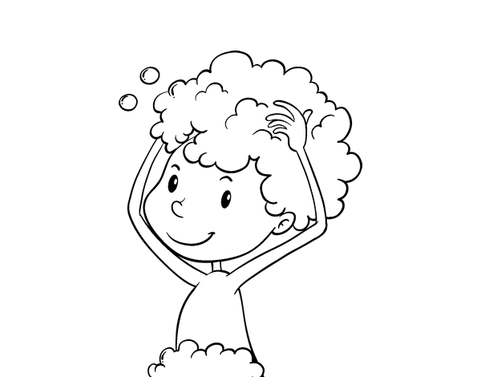 | Name_________  Period________

- Write a balanced reaction for the combustion of C₃H₈.

- Solid sodium reacts with chlorine gas to form solid sodium chloride . Write a balanced equation including phase symbols.

- aqueous sodium sulfate reacts with aqueous calcium chloride to form
aqueous calcium sulfate and aqueous sodium chloride Write a balanced equation including phase symbols.

- BALANCE THIS ____Mg(s) + ____Cl₂(g) → ____MgCl₂(s)

- Solid aluminum oxide decomposes into solid aluminum and oxygen gas. Write a balanced equation including phase symbols.

- ____Fe(s) + ____H₂O(l) → ____Fe(OH)₃(s) + ____H₂(g)

- Solid magnesium and nitrogen gas combine to form solid magnesium nitride. Write a balanced equation including phase symbols.

- What does the Law of Conservation of Mass say must ALWAYS ALWAYS ALWAYS be true about the mass of the Reactants in any reaction in the history of the entire Universe?

- When solid potassium chlorate is strongly heated in a flame it forms oxygen gas and solid potassium chloride.

_________ + _________ _________ + __________

- Zinc and lead (II) nitrate react to form zinc nitrate and lead.

_________ + _________ _________ + __________

- ____ C₅H₁₂(g) + ____ O₂(g) → ____ CO₂(g) + ____ H₂O(g)

- ___ CO₂ + ____ H₂O ____ C₆H₁₂O₆ + ____O₂

- classify each of the reactions below as one of the folloing reaction types

COMBUSTION,
DECOMPOSITION,
COMBINATION,
SINGLE REPLACEMENT,
DOUBLE REPLACEMENT

  - ___________ SO₂ + O₂ SO₃
  - ___________ Fe + O₂ Fe₂O₃
  - ___________ Fe + CuSO₄ Fe₂(SO₄)₃ + Cu
  - ___________ Li + N₂ Li₃N
  - ___________ Na₂CO₃ Na₂O + CO₂
  - ___________ Zn + H₃PO₄ Zn₃(PO₄)₂ + H₂
  - ___________ Cl₂ + LiI LiCl + I₂
  - ___________ Zn + Pb(NO₃)₂ Zn(NO₃)₂ + Pb

If the statement is False, write a word in the blank to make it True.
- □True □False Thomson’s glass tube glowed on the end because it was being hit with atoms
__________________________
- □True □False If a neutral atom loses electrons it will become a cation _____________________________
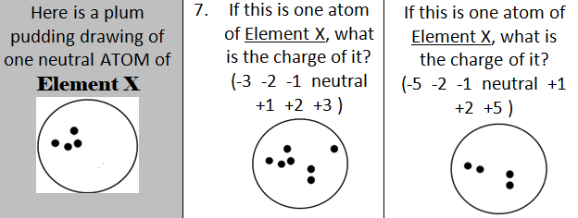
4. When 3M HCl is added to solid sodium carbonate, the contents of the test tube immediately starts bubbling and gets warm. Carbon dioxide gas, water vapor and sodium chloride are formed. In the LOL diagram below you should first show chemical energy changing to thermal energy and then in a separate step show heat leaving the system as an arrow. 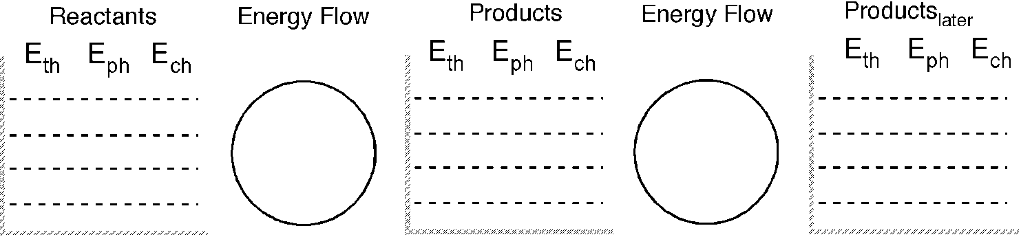
6. What type of reactions are the following?
Matching. Use each choice once. What type of reactions are shown here?
_______ AB + C CB + A  _______ A + B AB  _______ AB A + B  _______ AB + CD CB + AD | - combination (sometimes called synthesis)  - decomposition  - single replacement  - double replacement
- In an endothermic reaction, is the energy of the products less than or greater than that of the reactants?

- Convert each of the following energy units:
  - 8.1 kcal to cal

  - 2.50 kcal to J

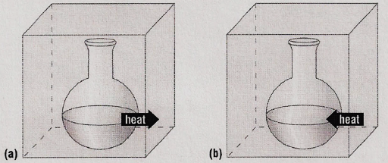
Some substances reacted in two flaskes. For each stzatement below, choose either Reaction A or Reaction B
- ________ For the substances in the reaction E_{ch} is decreasing
- ________ The reaction could be written A + energy B
- ________ The reaction could be written A B ∆H = -500kJ
- ________ The ∆H = + 300 kJ
- ________ The reaction is exothermic
- ________ The reaction would feel cold if you held the flask in your hand.
Energy in Chemical Reactions
- Classify the following as exothermic or endothermic:
- 550 kJ is released
- The energy level of the products is higher than that of the reactants.
- Classify the following as exothermic or endothermic reaction and give ΔH for each:
- Gas burning in a Bunsen burner: CH₄ + 2O₂ → CO₂ + 2H₂O + 890 kJ
- Dehydrating limestone: Ca(OH)₂ + 65.3 kJ → CaO + H₂O

- In the reaction below, connect the conjugate pairs with a line. Write “acid” or “base” below each of the four substances.

NH₄⁺ + OH⁻ $⇆$ HOH + NH₃

x
- Next to each, write its conjugate base:

NH₄⁺______ NH₃ ______
NH₂- ______ H₂O ______
H₃O⁺ ______

