Lab: How do moving particles do at different temperatures?  East HS chemistry  Mr. Genest | 2.3 | Name _____________________  Period __________ Unit_________
- Open a browser, such as Google Chrome Click on the link: http://phet .colorado.edu/en/simulation/states-of-matter-basics OR from Google, search PHET STATES OF MATTER
- Click on States of Matter: Basics
- Once you see the simulation screen shot, click “Run Now!”
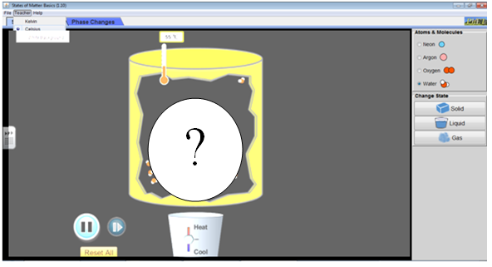
Explore(10 minutes)
Take 10 minutes to freely explore the simulation. List five things you discover.
1)
2)
3)
4)
5)

 | NEON
 | Solid | Liquid | Gas |  |  | What is the temperature when solid changes to liquid? | What is the temperature when liquid changes to gas?
Shape of the glop of matter |  |  |  |  | neon
Space between atoms |  |  |  |  | argon
Describe the motion of the atoms |  |  |  |  | oxygen
Draw a picture |  |  |  |  | water

