Lab: How do we sketch particles differently as Solid, Liquid, and Gas?  East HS chemistry  Mr. Genest |  | First Name _____________________  Last Name __________________  Period __________  Be neat, -1 if you skip a blank above…
- Open a browser, such as Google Chrome Click on the link from our class website for today, OR http://phet .colorado.edu/en/simulation/states-of-matter-basics OR from Google, search PHET STATES OF MATTER
- Click on States of Matter: Basics
- Once you see the simulation screen shot, click “Run Now!” OR press Play.
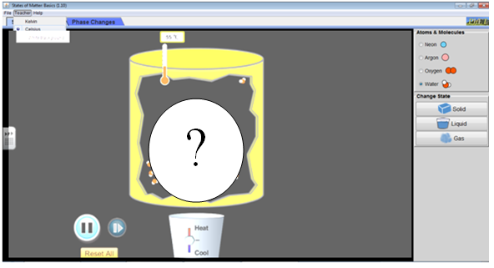

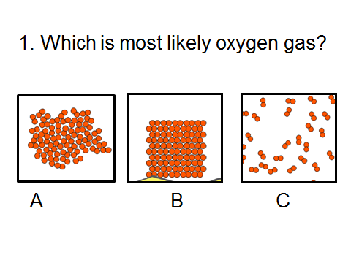 | 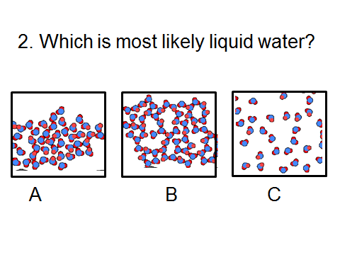

Read this: set your computer for ‘NEON’
 | Solid | Liquid | Gas
Shape of the glop of matter |  |  |  |  | A single Iron particle looks like this 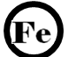  Draw your predicted particle picture in each box | Draw 8 particles of GAS Iron | Draw 8 particles of SOLID Iron
Use a ruler to measure in mm the space between atoms |  |  |  |  | A single cyanide particle looks like this  Draw your predicted particle picture in each box | Draw 5 particles of SOLID cyanide | Draw 5 particles of LIQUID cyanide
Measure the motion of each particle using both time and distance units somehow (there is no right answer) |  |  |  |  | Tell an artist how to draw solids, liquids, gases..  On separate paper, write an instruction paragraph that starts out “An artist that is trying to draw cartoons of Solid, Liquid, and Gas particles, should draw them as follows…”  Staple your paragraph to this paper
Draw a picture

