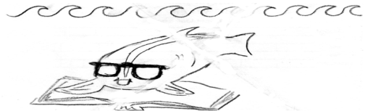 |  | Guid  ed  Read  ing : Phases and Energy | Name___________________  Date____________________
To be completed while reading the class textbook ‘Chemistry’ by Wilbraham
Write in full sentences of your own wording to receive full credit.
You should memorize these answers, including the meaning of words that are in italics.
Checked at the end of class but not handed in; show it to me for a stamp.
Liquids.(p. 274), first paragraph
- What is different about attraction for liquids versus gases?

Energy of liquids (p. 274) second paragraph
- what are the three things that molecules do that gives them kinetic energy?
- copy the definition of kinetic energy from the glossary

“The Dance” (p.274) second paragraph
- What pulls molecules close together according to the book (two word technical term).
- According to the book, what can fight against the force you just named?
- The video on Tuesday (see link on class webpage) said molecules are in a dance. What were the only two motions allowed in that dance?

Contrasting Liquids versus Solids (pp. 274 & 280)
- Sketch and label liquid particles and solid particles based on Figure 10-5 and 10.12. You may simplify your ignore the white circles to simplify your drawing.

Changing phase (p.280)
- At the melting point what thing overcomes what other thing? Write in a complete sentence.
- If you know that the freezing point of pure titanium is 1668 °C, what do you know about the melting point?
Teacher’s Stamp:

