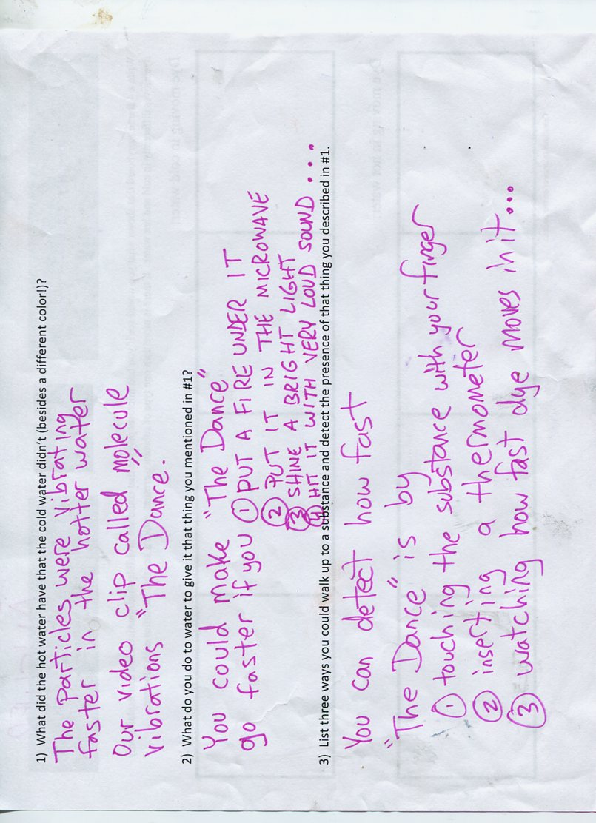

October 15, 2014
Purpose: After today I will know more details about ‘The Dance’ of solid and liquid particles so that I can give a detailed explanation of how energy causes them to change.

Warmup,copy and complete: The chocolate bunny in yesterday’s video changed from solid to liquid when energy was (added/ removed).

Memorize this by Friday:
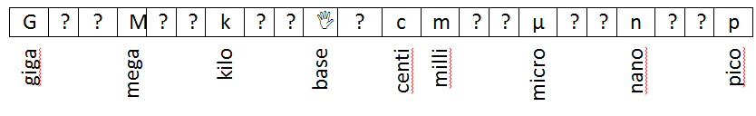

- In the cartoon yesterday we saw that all molecules do “The Dance”; the molecules first attract together and then repel apart.

- The amount of attraction depends on what type of molecule it is. All molecules have some attraction. This attraction is called ‘Intermolecular Force’

- The amount of repelling depends on how fast the molecules do “The Dance”.

- To change solid to liquid, all we need to do is increase the speed of the dance.
Ways to do this:

- To change liquid to solid, all we need to do is decrease the speed of the dance.
Ways to do this:

Decide who in your group had the best cartoon for the Homework.
Bring it up here and photograph it.

