Celsius and Kelvins  East.H.S. ©λ€M|5+rγ  visit http://genest.weebly.com | 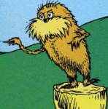 | Name_________________  Date__________________  Come for assistance and cheerful encouragement after school Tues, Thurs, every day at lunch
- We should MEMORIZE three common temperature scales: Sketch a third thermometer in the space to the right. Label it “Thermometer C”: It should look the same as the other two thermometers (draw the box, the lines, etc.).

Thermometer A |  | Thermometer B

- How to read thermometers:
    - Read to the nearest line.
    - Write that number down.
    - Estimate how far you are between the lines.
    - Write that after the decimal point.

For example, write the temperature of each thermometer:
______ degrees celsius |  | 33 34 35 36 37 38 39 40 41

______ degrees celsius |  | 33 34 35 36 37 38 39 40 41
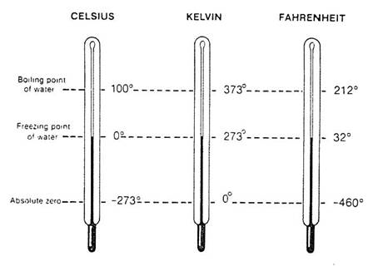
- Converting.
  - Based on the picture at right, what number do you want to add to degrees Celsius to turn them into Kelvins?
You should add ___________
  - Based on the picture at right, what number do you want to subtract from Kelvins to turn them into degrees Celsius?
You should subtract ___________
We will never convert between Fahrenheit and other temperatures in this class. You should know the numbers you wrote for question #1 though.

For example:
100 °C = _______ K |  | 573 K = _______ °C
4 °C = _______ K |  | 673 K = _______ °C

- How well can you memorize? Write numbers onto each thermometer to match the three indicated amounts of temperature Try not to look at the other side of your class notes. . .

Degrees Fahrenheit |  | Degrees Celsius
 | boiling water  human body  frozen water |  | boiling water  human body  frozen water
Write the symbol for degrees Fahrenheit: |  | Write the symbol for degrees Celsius |  | Write the symbol for Kelvins

- You decide to boil water to cook noodles. You place the pan of water on the stove and turn on the burner.
a. How does the behavior of the water molecules change as the pan of water is heated?

b. What about your answer to (a) would change if there were more water in the pan?

- What property of matter best describes the way a typical alcohol thermometer works? Explain (in terms of energy transfer) why the alcohol level in the thermometer rises (or falls) when you place the thermometer in contact with both warmer (or colder) objects.

- If you feel feverish, why can't you take your own temperature with your hand?

- Your older brother announces that the lid to a jar of pickles from the refrigerator is “impossible” to loosen. You take the jar, hold the lid under the hot water from your sink’s faucet for a few seconds, and calmly open the jar. Your brother, when faced with this blow to his pride, claims that he loosened it for you. What knowledge of materials have you applied in this situation that really explains how you were able to open the lid?

- Describe how Anders Celsius devised the temperature scale that bears his name.

- Which would feel warmer to the touch - a bucket of water at 50˚C or a bathtub filled with water at 25˚C? Which of these stores more energy? Account for any differences in your answers to these questions.

