Today:
hw check
two videos, take notes 5 min. each
demonstration: how to build a thermometer
Lorax homework: solve pages 1 & 2 together
Tips on how to study for tomorrow’s quiz

Purpose:
How do we make invisible heat visible?

WARMUP :

50 Mm = ____________ mm

#1 Video Notes: Expansion and Contraction

#2 Video Notes: How to measure temperature

#3
A thermometer works because invisible vibrating matter transfers KINETIC ENERGY to the glass and then to the liquid, causing the liquid to expand.

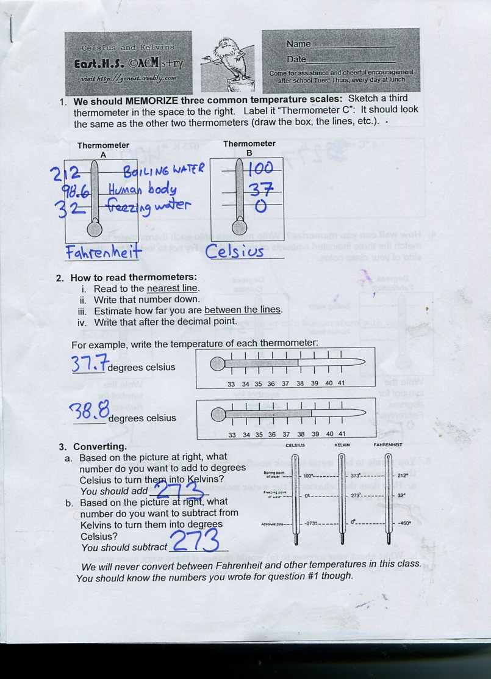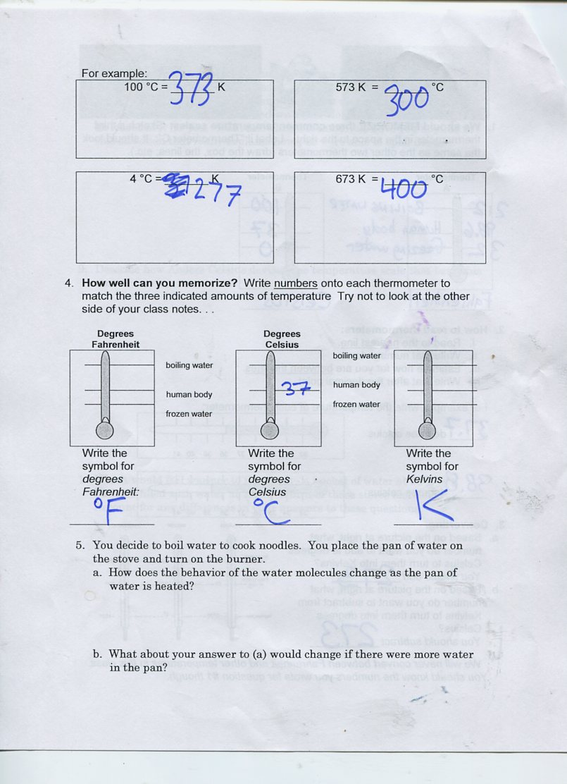

Homework: Finish the Lorax Sheet. Do a good job – your group will present one of the homework problems tomorrow.

