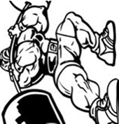  Avogadro's Law  (LAB DATA) |  | - Draw one molecule into Box A and three molecules into Box B.  - Cut four strips of colored paper, as skinny as possible.  - Draw tiny arrows all over both sides of each strip, all going toward the same end of the paper.  - Hold the tip of your strip to your molecule in Box A. Now use the paper to show the path your gas particle could move Fold, hit, bend, hit, bend, hit...  - Tape or glue your paper to the box  Box A. In here there is one gas molecule at 200 kelvins. It bounces off the walls _______ times. Box B. In here there are three gas molecules at 200 kelvins. They bounce off the walls _______ times.
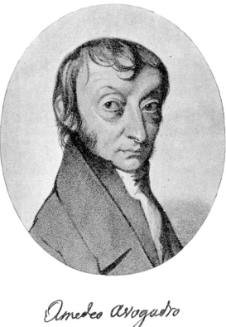 |  | - Make a little table: |  | - Make a graph for your table (label your axes) | - When the gas collides with the wall of the box it causes pressure. Based on the number of hits, pressure seems to be (directly / inversely) related to number of gas molecules.  - How would you do steps #1 - #5 differently if you were trying to show a colder gas or a hotter gas?
 |  | # of molecules | # of wall hits
- Complete the sentence. “When the number of molecules goes up by three, the pressure on the walls goes up by …”

Example:
Your molecule + paper strip path might look like this when you're done

