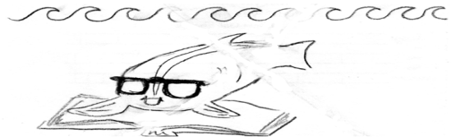 |  |  | Guid  ed  Read  ing : Phases and Energy |  |  | Name___________________  Date____________________
To be completed while reading the class textbook ‘Chemistry’ by Wilbraham (if you’re at home doing this, check the website for the textbook as a PDF)
You should memorize these answers, like it’s class notes, for a quiz on Friday and for the Test on October 22.
Checked at the end of class but not handed in; show it to me for a stamp.
(p. 267), Kinetic Theory Rule #1 | A gas is composed of ______________.  What is the volume of these particles? __________________________  What is between the particles? ______________________________  How attractive are gas molecules to each other? (not at all / slightly attractive / veeeerrrrryyyyy attractive )
(p. 267), Kinetic Theory Rule #2 | At room temperature, what is the velocity of an oxygen molecule? _______________  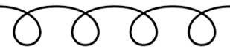 this is not how molecules of a gas travel Draw how they really travel:
Energy of liquids (p. 274) second paragraph
- what are the three things that molecules do that gives them kinetic energy?
- copy the definition of kinetic energy from the glossary

(p. 271), Last Paragraph | When temperature increases, what else increases? __________________________________________  As a particle cools down, what happens to its velocity? ________________________________________  What is special about the temperature -273 °C? _____________________________________________________________________  ______________________________________________________________________________________________________________  What temperature is absolute zero in Kelvins? ________________ In degrees Celsius? _________________________
“The Dance” (p.274) second paragraph
- What pulls molecules close together according to the book (two word technical term).
- According to the book, what can fight against the force you just named?
p. 272 | When Kelvin temperature doubles, what happens to the kinetic energy?
p. 74 | If some lemonade is 310 kelvins, what is its temperature in °C?  If a hamburger is supposed to be cooked until it is 90 °C, what is this in kelvins?
Changing phase (p.280)
- At the melting point what thing overcomes what other thing? Write in a complete sentence.
- If you know that the freezing point of pure titanium is 1668 °C, what do you know about the melting point?
Page 284  Look at the three colored parts of Figure 10.18 |  | What are the three common phases of matter? _____________, ______________, ____________________
 |  | Teacher’s Stamp:

