review #1 for Thursday’s Test  East.H.S. ©λ€M|5+rγ  visit http://genest.weebly.com |  | Name_________________  Date__________________  Come to study. This week I am here Tues. & Thurs after school until 4:45 and every day at lunch

Fill in every grey box with the correct word and the correct symbol

 | ? | ? |  | ? | ? | k | ? | ? |  | ? |  | m | ? | ? |  | ? | ? |  | ? | ?
 |  |  |  |  |  | kilo |  |  | base |  |  | milli
- What are three things that molecules do that give them kinetic energy?
- Chocolate bars are solid but they still have an odor. Draw a particle picture in this box between the nose that explains this:
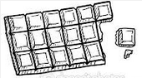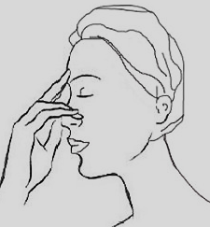

- The video on Tuesday described molecules as doing 'The Dance'. What are the only two moves allowed in this dance?

- How well can you memorize? Write numbers onto each thermometer to match the three indicated amounts of temperature Try not to look at the other side of your class notes. . .

Degrees Fahrenheit |  | Degrees Celsius
 | boiling water  human body  frozen water |  | boiling water  human body  frozen water
Write the symbol for degrees Fahrenheit: |  | Write the symbol for degrees Celsius |  | Write the symbol for Kelvins

- Which will have more energy:
  - a solid substance
  - the same substance but as a liquid
- If the freezing point of neon is negative 249 °C, what is the melting point of neon?

Use your metric cheat sheet to answer these questions. By this Friday you should be able to draw this cheat sheet from memory.

- In every 1 meter there are __________ micrometers.
- In every 1 megameter there are __________ meters.

Underline the GIVEN (the lonely unit that is not paired with another unit). Circle CONVERSION FACTORS (pairs of units). Draw a box around the GOAL (the unit the answer should be in).
If brats at State Street Brats have a mass of 650 grams each and you eat 1 brat every 15.00 minutes, how many grams of brat will you eat in 18.1 minutes?
Solve:

