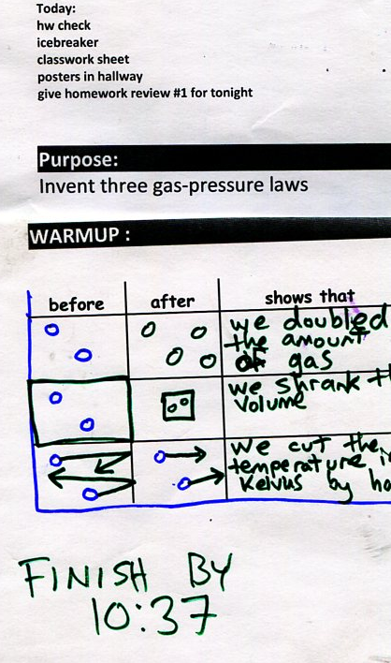
h
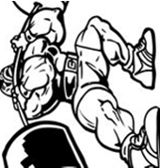  Gas Laws Learned from folded paper! |  | Directions: For each square draw a before box and an after box. Then at the bottom of the box, finish the sentence stem. | - What happens to the pressure in a box when the number of gas molecules is doubled in the box?  “My law of gas particle number says that if you…”  A qualitative graph (a graph with no numbers) of pressure vs particle number would look like this

- What happens to the pressure in a box when the temperature of gas molecules is doubled in the box?  “My law of gas particle number says that if you…”  A qualitative graph (a graph with no numbers) of pressure vs temperature would look like this | - What happens to the pressure in a box when the box gets twice as tall and twice as wide?  “My law of box size says that if you…”  A qualitative graph (a graph with no numbers) of pressure vs box size would look like this | - What is the only temperature scale allowed for doing gas law problems?  - How do you draw hot gas particles and cold gas particles (show)?  - What causes pressure (explain by using particles).

