kinetic molecular theory  East.H.S. ©λ€M|5+rγ  visit http://genest.weebly.com |  | Name_________________  Date__________________  Come for assistance and cheerful encouragement after school Tues, Thurs, and every day at lunch

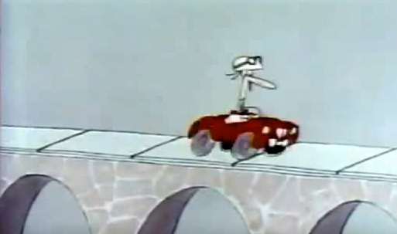
- In the Eureka videos we saw sidewalks and especially bridges are made from separate pieces and have cracks as shown above. With words and drawings, explain what BAD RESULT would happen if a bridge were constructed without these cracks.
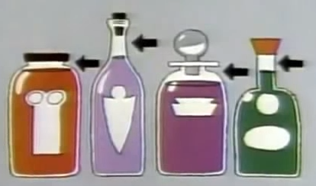
- In the Eureka videos we saw that bottles of liquids are always filled as shown in the picture above. With words and drawings, explain what BAD RESULT would happen if these bottles were filled all the way to the top.
- A diagram in a chemistry textbook shows the magnified view of a flask of air seen here at the right. What do you suppose is between the dots (the dots represent air molecules)?
- What is kinetic energy?
and
Show with a picture, the three ways molecules can have kinetic energy.

- Are particles of H₂O gas farther apart or closer together than the particles of H₂O liquid?
and
In words or pictures explain why H₂O gas is more compressible than H₂O liquid.
- Are particles of iron gas farther apart or closer together than the particles of iron solid?
and
In words or pictures explain how the density of iron gas would be different than the density of iron solid.
- Consider two different containers, each filled with 50 million molecules of neon at negative 247 °C. One of the containers is very strong steel and won’t change shape, no matter what. The other is stretchy, like a balloon. If you raise the temperature by ten degrees celsium, what happens to the phase of each ? What happens to the density of each? Explain with words and pictures.
- Jar X and Jar Y both contain a dozen neon atoms.
Jar X is at 100 kelvins and is heated to 200 kelvins. Jar Y is at 100 °C and is heated to 200 °C.
In which jar did the motion of particles increase the most? [In other words, in which jar’s particle velocity experienced the greatest change?] Answer with words and pictures.

You may find the following  information useful. | silicon mp = 1414 °C bp = 3265°C  neon mp = -249°C bp = -246°C (note the negative)  gallium mp = 30°C bp = 2400°C
- Draw seven particles of each substance at the indicated temperature. Use what you learned in the computer lab and in our cartoon videos (you may re-view these cartoons at the class website. There will be true-false questions on Friday’s test covering these videos:
Silicon at 2000 °C |  | Neon at 0 °C
- If a mud puddle in the street is 285 kelvins, what is its temperature in °C

- If a dog is left in a car that is at 26 °C, what is this in kelvins?

