Teach:
where's oil
where's air
why the rubber band
demonstrate proper holding upright and sliding

Pre-Lab

- The dot shows a drop of oil stuck in a tiny test tube.
In Tube (A), below, draw particles to represent the air trapped inside the tube by the drop of oil.
- Draw your prediction for where the bubble should be in the other two  - 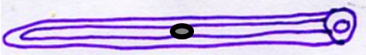 at 20°C  - at 40°C  - at 0°C | - Some students were trying to measure the radius and the length of trapped gas. Write a happy face next to each correct measurement and a sad face next to each useless measurement.  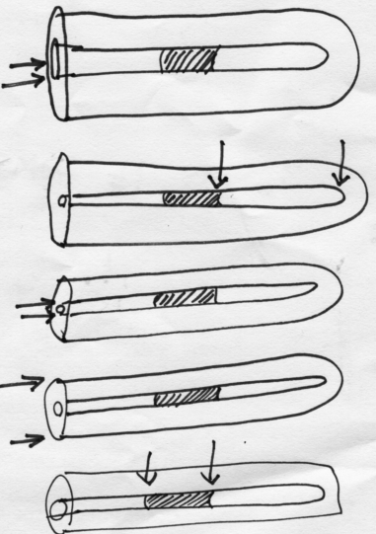
- Get a ruler. While looking at Tube A, above,
  - use the ruler to measure the radius of the trapped gas _____________
  - Measure the length of the trapped gas_____________
  - Using the formula for volume of a cylinder, calculate to correct significant figures the volume of gas trapped in (A). _____________
- Circle one or more. The speed of gas particles should double if the temperature doubles in ( °C /°F / K )
Stop. Get a stamp from the teacher before continuing

- Grab your equipment:
one Rosevear tube, one pair of tweezers, one ruler , one thermometer
at the end of the lab, please put all of this away

- Data table (make data tables on the back of this sheet as discussed in class).
First Name_____________ Last _______________ Period ______
Homework
- Make a graph of volume(cm³) vs temperature(kelvins):
- label your axes, including units
- choose your scale so your graph is not too scrunched up
- Put a title at the top that tells someone what this is a graph of
- plot your four or five points by drawing a dot with a square, circle, or triangle around the dot.
- draw a best fit line that is straight. Your line should not ‘connect-the-dots’
- Do NOT include the point 0,0 as a data point. We did not collect any data for this temperature.

- Make a graph of V/T versus Temperature(K)
- label your axes, including units
- choose your scale so your graph is not too scrunched up
- Put a title at the top that tells someone what this is a graph of
- plot your four or five points by drawing a dot with a square, circle, or triangle around the dot.
- draw a best fit line

- Find the temperature of absolute zero: (1) On your first graph, find the point where your line would have zero volume. (2) Write down that temperature. That is YOUR Absolute Zero.

