Review #1  East.H.S. ©λ€M|5+rγ  visit http://genest.weebly.com |  | Name_________________  Date__________________  Come for assistance and cheerful encouragement after school Tues, Thurs, and every day at lunch

- What day is the test? ____________________ Are there re-takes? ____________ Is it open notes? _________________ Can you use your own non-graphing calculator? _________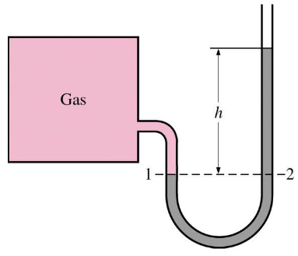
- If this manometer is in a room that is at standard pressure, and “h” is 7.0 millimeters of mercury the pressure of the gas inside the square box is ___________

- If gas in this box is at a pressure of 751 torr and the height of the mercury shown byt h is 13 mm , the ambient pressure in the room must be __________
If this manometer and box are in a room in Madison (elevation 800 feet) and they are moved to Poughkeepsie, New York (elevation 60 feet) the height of liquid shown by “h” would
  - decrease
  - stay the same
  - increase
- If this manometer and box are in our chemistry room and are moved out to the student parking lot the height of liquid shown by “h” would
  - decrease
  - stay the same
  - increase
- If this manometer and box contained 30 mL of gas at standard temperature and then the temperature of the gas were changed to 250 kelvins, the height of liquid shown by “h” would
  - decrease
  - stay the same
  - increase

This isn’t a review that has everything you need to know. For that, go to all your old notes and sheets since September 26

- If this manometer and box contained 5x10²² atoms of helium and then you added another 2x10²² atoms of helium, the height of liquid shown by “h” would
  - decrease
  - stay the same
  - increase

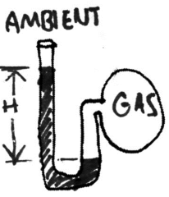 If the room pressure is 745 mmHg and the height of the mercury at ‘H’ is 4 mm, what is the pressure of the gas in the sphere? | 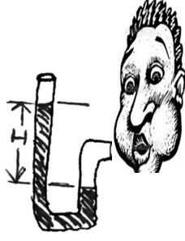  If this fellow’s breath is supplying a pressure of 790 mmHg and the room ambient pressure is 748mmHg, how tall is the part of the figure that is labeled ‘H’?
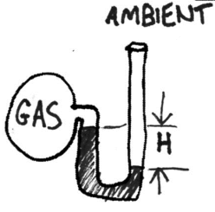 If the room pressure is 765 mmHg and the height of the mercury at ‘H’ is 9 mm, what is the pressure of the gas in the sphere? | 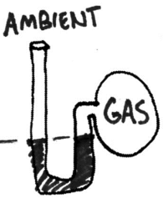If the ambient pressure is 761 mmHg, what is the pressure of this gas?
If the stuff in the gas t tank is at 788 mmHg and the height of the mercury at ‘H’ is 7 mm, what is the pressure of the gas in the room? | If the room pressure is 750. mmHg and the ‘H’ is 3 mmHg, what is the pressure of this gas?

- Find the age in seconds of a man who is 91.35 years old.

- Step One: Underline the starter unit (the unit that is not paired with another unit.Circle pairs of units. Draw a box around the goal unit. Your school club sold 600 tickets to a chili supper. The chili recipe for 10 persons requires 2 teaspoons of chili powder. How many teaspoons of chili powder will you need altogether?
- If aluminum has a density of 2.70 grams per mL, find the volume, in liters, of 2.55x10⁻⁷ kg of aluminum. You will need to know your memorized metric conversions.

- Rewrite each as scientific notation:

  - 567890
  - 0.000032
  - 2.7
  - the year you were born

- Step One: Underline the lonely unit (the unit that is not paired with another unit.Circle pairs of units. Draw a box around the unit the answer should be in.
If a beachcomber finds a copper coin with a volume of 0.0003760 liters, how many atoms of copper did the beachcomber find? Assume that 255 atoms of copper have a mass of 2.69 x 10⁻²⁰ grams. Also assume that the density of copper is 8.98 grams per mL.
Step Two: Solve below using dimensional analysis. Choose words before numbers.

- Show with a picture, the three ways molecules can have kinetic energy.

- Jar X and Jar Y both contain a dozen neon atoms.
Jar X is at 100 kelvins and is heated to 200 kelvins. Jar Y is at 100 °C and is heated to 200 °C. In which jar did the motion of particles increase the most?

- Your older brother announces that the lid to a jar of pickles from the refrigerator is “impossible” to loosen. You take the jar, hold the lid under the hot water from your sink’s faucet for a few seconds, and calmly open the jar. Your brother, when faced with this blow to his pride, claims that he loosened it for you. What knowledge of materials have you applied in this situation that really explains how you were able to open the lid?

- If you feel feverish, why can't you take your own temperature with your hand?

