What are RATIOS good for?  EHS Cλ3MIs+rγ  Mr. Genest |  | Name _________  Date __________  Tutors! Adults! Help this young chemist by visiting http:genest.weebly.com with any smart phone

Multiplication with units. Use a calculator. Your answer should have units written as one or more words. Round to correct sig figs
$$\frac{75 cm}{}*\frac{3.5 cm}{12.87 liters}=$$  $$\frac{91.2 grams}{}*\frac{117 pretzels}{594.4 grams }=$$ | $$\frac{1.2 grams}{}*\frac{1 mL}{11.7 grams}=$$  $$\frac{1.2 grams}{}*\frac{11.7 grams}{1 mL }=$$
.
- Numbers that are in a relationship (use your common sense)
- _____ EGGS = _____ DOZENS  - _____EYES = _____HUMAN  - _____LEGS = _____ SPIDER | - _____mL = _____ liters  - _____ kilometers = _____ millimeters  - _____yards = _____ football field

- Rewrite the six numbers-in-relationships from above as ratios there are two versions of each, one an upside down version of the other.
  - ratios for eggs and dozens could be $(\frac{}{ …………………..})$ or $(\frac{}{ …………………..})$
  - ratios for eyes and humans could be $(\frac{}{ …………………..})$ or $(\frac{}{ …………………..})$
  - ratios for mL and liters could be $(\frac{}{ …………………..})$ or $(\frac{}{ …………………..})$
  - ratios for yards and fields could be$(\frac{}{ …………………..})$ or $(\frac{}{ …………………..})$

- Insert one of your ratios from above into each equation below in a way that the units will cancel. Use a calculator to write an answer that has correct UNITS and sig figs.

- 225 eggs _{x} $\left(\frac{}{ …………………..}\right)=$  - 13 humans _{x} $\left(\frac{}{ …………………..}\right)=$ | - 9.90 liters _{x} $\left(\frac{}{ …………..}\right)=$  - 55 football fields _{x} $\left(\frac{}{ ……….}\right)=$

- Estimate the level of liquid in the four containers. Remember: read between the lines and add only ONE MORE digit
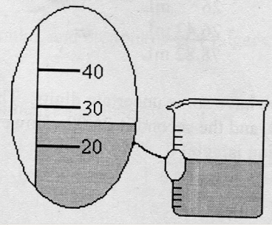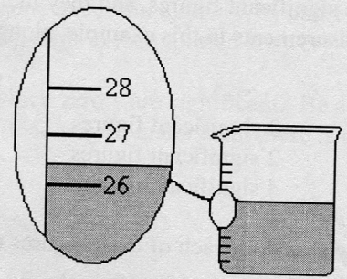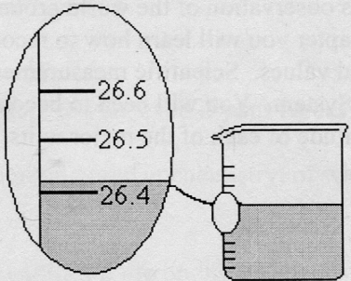

_____________ _____________ _____________ _____________

- Equalities based on metric system and on the graph shown here:
- Slope of A  - Slope of B | 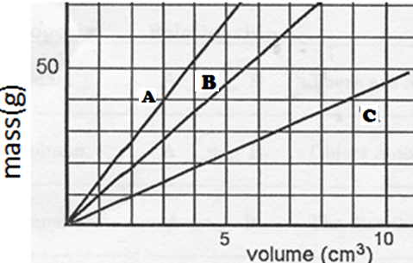

- Use your two slopes from the graph to write ratios
  - Two ways to write a ratio based on the Slope of Line A are
$(\frac{}{ …………………..})$ or $(\frac{}{ …………………..})$
  - Two ways to write a ratio based on the Slope of Line B are
$(\frac{}{ …………………..})$ or $(\frac{}{ …………………..})$
  - Two ways to write a ratio based on the Slope of Line C are
$(\frac{}{ …………………..})$ or $(\frac{}{ …………………..})$

VI Insert one of your ratios from above into each equation below in a way that the units will cancel. Use a calculator to write an answer that has correct UNITS and sig figs.
- 225 cm³ of “A” _{x} $\left(\frac{}{ …………………..}\right)=$  - 4.50 g of “A” _{x} $\left(\frac{}{ …………………..}\right)=$ | - 0.48 g of “B” _{x} $\left(\frac{}{ …………..}\right)=$  - 1.65 cm³of “B” _{x} $\left(\frac{}{ …………………..}\right)=$

