Review #2  East.H.S. ©λ€M|5+rγ  visit http://genest.weebly.com | 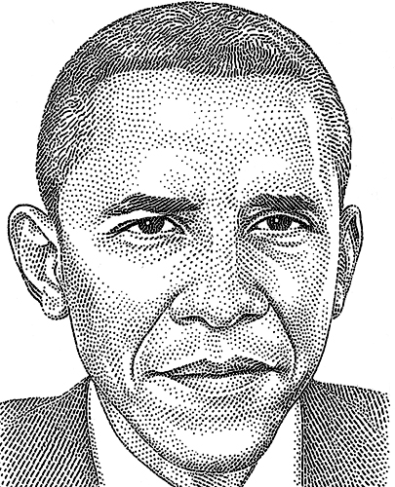 | Name_________________  Date__________________  Come for assistance and cheerful encouragement after school Tues, Thurs, and every day at lunch

- What day is the test? ____________________ Are there re-takes? ____________ Is it open notes? _________________ Can you use your own non-graphing calculator?

The following numbers will always be given to you and don't need to be memorized:
°celsius + 273 = kelvins
760. torr = 760. mmHg = 1.000 atm = 101.3 kPa

- Why do barometers contain mercury, rather than water or another fluid.
- There are many correct answers to the following question. Name a place on Earth where the ambient pressure is usually more than in Madison
- Name a place on Earth where the ambient pressure is usually less than in Madison.
- Name and draw the device we use to measure atmospheric pressure. Label the part of it that is usually 760. mmHg when at sea level.
In Figure 4 below, a graph shows the relationship between mass and volume for two substances, A and B. Use the graph to answer questions about these two substances.
- The diagram at right shows a manometer connected to a flask. The mercury levels are measured in mm. The pressure in the room is 745 mm Hg. Determine the pressure of the gas in the flask. Show work. | 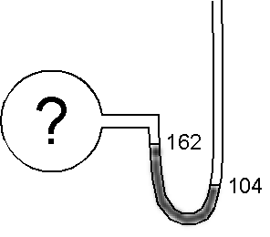

- Convert 33 kelvins to °C.

- Convert 100 °C to kelvins.

- Convert -100 °C to kelvins.

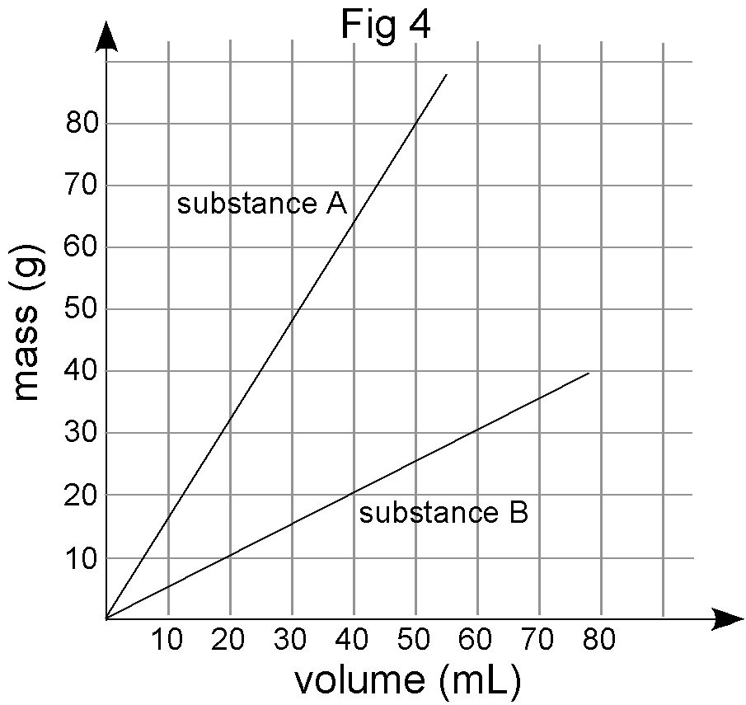 | Two Pan Balance  A B
- You have built a simple two-pan balance shown above to compare the masses of substances A and B. What would happen to the balance if you put equal masses of A and B in the two pans? Equal volumes of A and B in the two pans? Explain your reasoning.

b) Find the slope of the line for both A and B using correct units. State the physical meaning of the slope for each substance.

c) If you put 10.0 mL of A in one balance pan, what mass of B would you need in the other pan to make it balance? Explain your reasoning.

d) If you put 35.0 mL of B in one balance pan, what volume of A would you need in the other pan to make it balance? Explain your reasoning.

e) Water has a density of 1.00 g/mL. Sketch the line representing water onto the graph in Figure 4.

f) Determine whether substance A and B will sink or float when placed in a bucket of water.
b
A: sink float B: sink float (circle correct response)
- If two variables are directly related they will look like graph number _________  - If two variables are directly related they will look like graph number _________  - A graph of pressure vs number of gas molecules would look like graph number ______ | 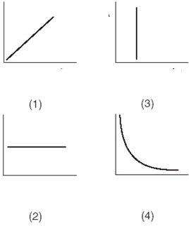

- When temperature increases, what else increases? __________________________________________

- What temperature is absolute zero in Kelvins? ________________ In degrees Celsius? _________________________
- Which will double the kinetic energy of a block of aluminum, going from 300 °C to 600°C or going from 300K to 600K.
  - neither
  - doubling the Celsius
  - doubling the kelvins
  - both
- If you know that the freezing point of pure titanium is 1668 °C, what do you know about the melting point?
- If a beachcomber finds one copper penny every 355 minutes, and copper pennies have a mass of 2.48 grams, how many grams of copper will the beachcomber find in 7.25 hours?

You may find the following  information useful. | silicon mp = 1414 °C bp = 3265°C  neon mp = -249°C bp = -246°C (note the negative)  gallium mp = 30°C bp = 2400°C
- Draw ten particles of each substance at the indicated temperature. Use what you learned in the computer lab and in our cartoon videos (you may re-view these cartoons at the class website. There will be true-false questions on Friday’s test covering these videos:
Neon at -247 °C |  | Neon at -250 °C

