Rates and and  EHS Cλ3MIs+rγ  Mr. Genest | 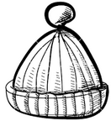 | Name_________________  Date__________________  Tutors! Adults! Help this young chemist by visiting http:genest.weebly.com with any smart phone

- Definition of a ratio: | - Definition of a rate:

- Write ‘rate’ above anything that is a rate. Write ‘ratio’ below anything that is a ratio.

________ | ________ | ________ | ________ | ______
$$\left\{\begin{aligned}For every 5 people that \\ get a “C” in chemistry there \\ are 2 people who get an “A”\end{aligned}\right\}$$ | $$\left\{5 :6\right\}$$  Or if you prefer $\left\{\frac{5}{6}\right\}$ | $$\left\{33g/mL\right\}$$ | $$\left\{\begin{aligned}My brother in \\ law buys 3 big \\ screen TVs \\ every 8 years\end{aligned}\right\}$$ | $$\left\{\frac{2.71}{3.14}\right\}$$
________ | ________ | ________ | ________ | ________

- Examine the graph at the right. Based on the best-fit line slope (which is already calculated at the top!) dream up three different rates: | 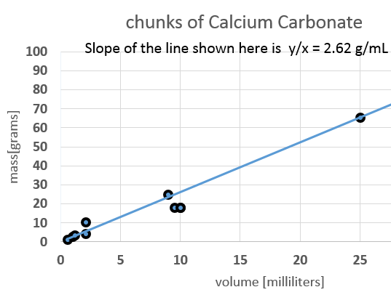  This is the real data from our September 27 experiment, finding the mass and volume of chunks of white rock. I took your numbers from the lab blog and put them in a spreadsheet.

- The two story problems below all relate to the Calcium Carbonate graph above. Insert one of your rates from above into each equation below in a way that the units will cancel.
- $\left(\frac{225 {cm}^{3}}{ ……1…..}\right)$ _{x} $\left(\frac{}{ ………..}\right)=$ grams | - $\left(\frac{225 grams }{ ……1…..}\right)$ _{x} $\left(\frac{}{ ………..}\right)=$ cm³

For the following, use your calculator’s key (on Casio) or key (on most Ti). Include units. Write the number your calculator gives and then round to correct significant figures. Never use the 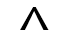key in chemistry.

- $\left(\frac{9.29x{10}^{12} beans}{1}\right)x\left(\frac{6.00x{10}^{12} seconds}{9.29x{10}^{4} beans}\right)=$
- $\left(\frac{6.00x{10}^{8} meters}{2.00 second}\right)x\left(\frac{9.29x{10}^{16} waves}{3.75x{10}^{5} second}\right)=$
- $\left(\frac{3.9x{10}^{-11} meters}{1}\right)x\left(\frac{4.2119x{10}^{12} grams}{6 x{10}^{4} meters}\right)=$
- $\left(\frac{9.29x{10}^{12} volts}{1}\right)x\left(\frac{9.29x{10}^{12} volts}{9.29x{10}^{4} m^{}}\right)=$

- Use data from #4 on the front if you wish. Calculate the volume of a block of Calcium Carbonate that has the dimensions:
L = 6.20 cm, W = 5.25 cm, H = 1.00 cm
Show your calculations and present your answer to the proper precision (number of significant digits).

