Applied Density Practice  EHS Cλ3MIs+rγ  Mr. Genest |  | Name_________________  Date__________________  Tutors! Adults! Help this young chemist by visiting http:genest.weebly.com with any smart phone

next year more scaffolding, for #2, #3, #5

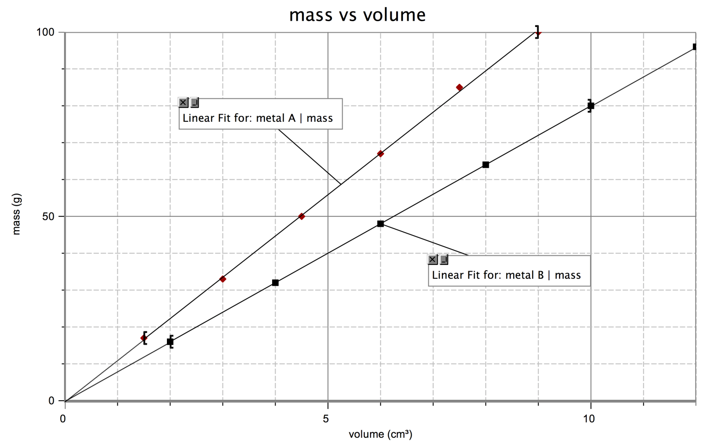

1. Determine the density of each metal (hint: density is just the slope of grams per mL). Show all your work and include appropriate units.

2. From the graph, estimate
a. the mass of 8.0 cm3 of metal A.

b. the volume of 70 g of metal B.

c. mark on the graph how you found the answers above.
3. Use the density of B as a factor to determine the answer to 2b. Show the set-up including how the units cancel.

4. Ethanol has a density of 0.789 g/cm³.
  - What is the mass of 225 cm³ of ethanol?

b. What is the volume of 75.0 g of ethanol?

5. What is the density of water in g/mL? What does that mean?

6. The cup is a volume widely used by cooks in the U.S. One cup is equivalent to
237 cm³. One cup of olive oil has a mass of 216 g; what is the density of olive oil?

7. What would you expect to happen if the cup of olive oil in question 6 is poured into a container of ethanol? Why?

Gold has a density of 19.3 g/ cm³. A cube of gold measures 4.23 cm on each edge:
8. What is the volume of the cube?

9. What is its mass? How many significant figures should you include in your answer and why?

10. A standard backpack is approximately 30cm x 30cm x 40cm. Suppose you find a hoard of pure gold while treasure hunting in the wilderness. How much mass would your backpack hold if you filled it with the gold? An average student has a mass of 70 kg. How do these values compare?

