Dimensional Analysis III  EHS Cλ3MIs+rγ  Mr. Genest | 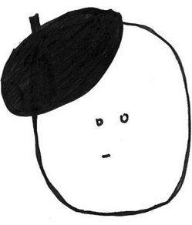 | Name_________________  Date__________________  Tutors! Adults! Help this young chemist by visiting http:genest.weebly.com with any smart phone

Show all set-ups!!
Given the following information:
1 quark = 2.9 whos 1 whos = 5 mabees 1 bug = 3.7 quarks 1 kuz = 3.2 mabees
1.) 3.0 quark to bug

2.) 1.3 mabees to quark

3.) 7.0 whos to bugs

4.) 8.75 kuz to quarks

5. 2.5 bug to kuz

6.) 2.0 X 10⁻³ quarks to mabees

7.) 900. quarks to whos

