mark-it-up conversion factors  East H. S. Cλ3MIs+rγ  Mr. Genest |  | Name_________________  Date__________________  Tutors! Adults! Help this young chemist by visiting http:genest.weebly.com with any smart phone

#1  Step One: Underline the starter unit (the unit that is not paired with another unit.Circle pairs of units. Draw a box around the goal unit.  If thorium is 11.7 grams per mL, what is the mass of 35.2 mL of thorium? (This is the question from last week's quiz)  Step Two: Write down the important info here.  What's the starter number?  What is the goal unit?  Write all the 'for every' statements that will make useful conversion factors.  Step Three: Solve below using dimensional analysis. Write words before you write numbers. | #2  Step One: Underline the starter unit (the unit that is not paired with another unit.Circle pairs of units. Draw a box around the goal unit.  What is the volume in cm³ of 400. grams of ethanol? Ethanol has a density of 0.789 g/mL. (This was on last week's cowboy sheet)  Step Two: Write down the important info here.  What's the starter number?  What is the goal unit?  Write all the 'for every' statements that will make useful conversion factors.  Step Three: Solve below using dimensional analysis. Write words before you write numbers.

#3  Step One: Underline the starter unit (the unit that is not paired with another unit.Circle pairs of units. Draw a box around the goal unit.  Pearl is planning a party for the defensive team of the Wisconsin Badgers (11 people). She wants to order enough lasagna so that every player can have 5 pieces. When she calls the restaurant, they tell her that a large lasagna is cut into 9 pieces and costs $34.18. How much money will Pearl need in order to feed all of her guests?  Step Two: Write down the important info here.  What's the starter number?  What is the goal unit?  Write all the 'for every' statements that will make useful conversion factors.  Step Three: Solve below using dimensional analysis. Write words before you write numbers. | 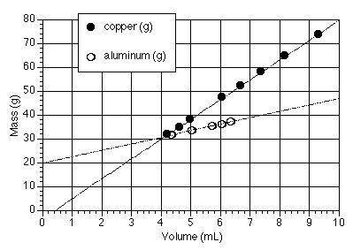  #4  Step One: Underline the starter unit (the unit that is not paired with another unit.Circle pairs of units. Draw a box around the goal unit.  What will be the mass in grams of a 842 mL aluminum unicorn? You need to find slope from the above graph to make a conversion factor.  Step Two: Write down the important info here.  What's the starter number?  What is the goal unit?  Write all the 'for every' statements that will make useful conversion factors. Strategy: You will need the slope from the above graph.  Step Three: Solve below using dimensional analysis. Write words before you write numbers.

