Using units correctly  EHS Cλ3MIs+rγ  Mr. Genest |  | Name_________________  Date__________________  Tutors! Adults! Help this young chemist by visiting http:genest.weebly.com with any smart phone

Don't calculate. Just fill in the blanks, using Figure 1 or prior knowledge to create some conversion factors. Look at your Monday notes if you're not sure what a 'conversion factor' is.

$$3. \left\{\frac{ ____ grams Zn}{ _____ mL Zn }\right\}$$
4. $\left\{\frac{ _____ pizza}{ _____ slices}\right\}$
$5. \left\{\frac{ _____ pepperonis}{ _____ slice}\right\}$
$$6. \left\{\frac{ ____mL Tin }{ _____ g Tin }\right\}$$
7. $\left\{\frac{ _____ mm dry Ash}{ _____ kPa}\right\}$
8. $\left\{\frac{ _____ hours }{ _____ miles}\right\}$
$$9. \left\{\frac{ _____ mL Al}{ _____ g Al}\right\}$$
10. $\left\{\frac{ _____ miles }{ _____ hour}\right\}$
$$\left\{\frac{ _____ mice }{ _____ box}\right\}$$

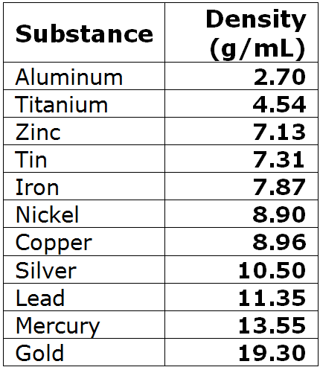 |  | 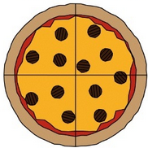
There are 5280 feet  in 1.00 mile (3 sig figs)  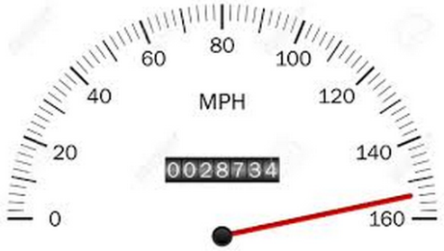 | 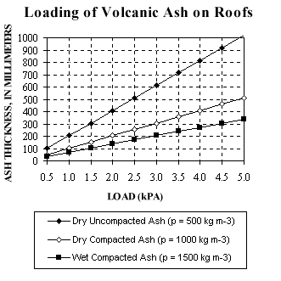
Figure 1

For the speedometer shown in Figure 1, what is the speed in feet per minute?  $$\frac{ 153 miles}{1 hour}×\frac{………… feet }{………..mile}×\frac{…….. hour}{………..minute }=$$ | If pepperonis are 15 grams each and you eat 2.5 pizzas, how many grams of pepperoni did you eat?  $$\frac{2.5 pizzas}{}×\frac{………… pepperonis }{………..pizza}×\frac{…….. gram}{………..pepperonis }=$$
What's the volume, in cm³ of 1.0 cubic mile of Sn?

$$\frac{1.0 {mile}^{3}}{}×\frac{… cm }{………..mile}×\frac{… cm }{………..mile}×\frac{… cm }{………..mile}=$$
If a small lead statue of Donald Trump has a mass of 8.3x10⁻⁴ grams, what is its volume?  $$\frac{8.3x{10}^{-4}g}{1}×\frac{………… mL }{………..g}=$$ | How much pressure will 1.53 meters of dry uncompacted ash make on a roof?  $$\frac{1.53 m}{}×\frac{………… mm }{………..m}×\frac{…….. kPa}{………..mm}=$$

There are 5280 feet
in 1.00 mile (3 sig figs)

Figure 1
.
#1  Step One: Underline the starter unit (the unit that is not paired with another unit.Circle pairs of units. Draw a box around the goal unit.  What is the volume of a 5.77x10⁶ gram piece of tin? You may need a table from Page 2. (BTW, Do you know the symbol for tin for this Friday's quiz?)  Step Two: Write down the important info here.  What's the starter number?  What is the goal unit?  Write all the 'for every' statements that will make useful conversion factors.  Step Three: Solve below using dimensional analysis. Write words before you write numbers. | #2  Step One: Underline the starter unit (the unit that is not paired with another unit.Circle pairs of units. Draw a box around the goal unit.  There are 30.48 cm in 1.000 feet and there are 5280 feet in one mile. What would be the mass, in grams, of 2.00 cubic miles of iron?  Step Two: Write down the important info here.  What's the starter number?  What is the goal unit?  Write all the 'for every' statements that will make useful conversion factors.  Step Three: Solve below using dimensional analysis. Write words before you write numbers.

