doing math with gas pressures  East.H.S. ©λ€M|5+rγ  visit http://genest.weebly.com | 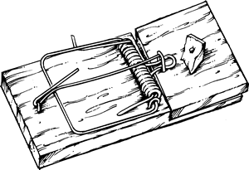 | Name_________________  Date__________________  Come for assistance and cheerful encouragement after school Tues, Thurs, or every day at lunch

Here are a bunch of helpful numbers and figures
0 degrees C = 273 kelvins 760. torr = 760. mmHg = 1.00 atm = 101 kPa = 101,300 pascals

- In a container of gas, when temperature decreases pressure usually ( decreases / increases ).
- In a container of gas, when number of particles decreases pressure usually ( decreases / increases ).
- In a container of gas, when volume decreases pressure usually ( decreases / increases ).
- Which of these units are suitable for solving gas math problems?

  - kelvins are (suitable / not suitable )
  - degrees celsius are (suitable / not suitable )

- Read the problem below and then just check one box (don’t do any math):  □ pressure will decrease  □ pressure will increase |  | - Read the problem below and then just check one box (don’t do any math):  □ pressure will decrease  □ pressure will increase
A krypton balloon contains 5,000,000 atoms of krypton at 77.111 kPa pressure. If more krypton atoms are added until there are 7,000,000 atoms in the balloon what will happen to the pressure? |  | A sample of ethane gas has a volume of 125 mL at 725 torr. If the volume is changed to 100 mL what will happen to the pressure?
- Read the problem below and then just check one box (don’t do any math):  □ pressure will decrease  □ pressure will increase |  | - Read the problem below and then just check one box (don’t do any math):  □ pressure will decrease  □ pressure will increase
A copper container has a volume of 555 mL and is filled with air at 298K. The container is immersed in dry ice. How will the pressure change? |  | When air in a steel cylinder is compressed from 10 L to 5 L, and temperature remains constant, what will happen to the gas pressure inside the cylinder?

- Set up and calculate an exact solution to the problem below. |  | - Set up and calculate an exact solution to the problem below.
A krypton balloon contains 5,000,000 atoms of krypton at 77.111 kPa pressure. If more krypton atoms are added until there are 7,000,000 atoms in the balloon what will be the new pressure (in kPa)? |  | A sample of ethane gas has a volume of 125 mL at 725 torr. If the volume is changed to 100 mL what will be the new pressure?

Write each number in standard decimal style, without an exponent

Write each number in scientific notation

For each pair of quantities mark < , =, or >.
Example: | U.S. Deaths due to bicycle accidents | __>__ | U.S. Deaths due to Ebola

 | - The temperature of 300°C water | ________ | The temperature of 300K water

 | - The mass of a 300 μg object | ________ | The mass of a 300 ng object

 | - 6.878 x 10¹ | ________ | 9.4608 x 10⁻⁶

 | - The value of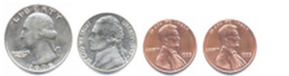 | _____ | The value of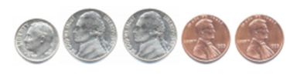

- write the answer to the correct number of significant figures
=
- write the answer to the correct number of significant figures
=

