energy practice  E.H.S. ©λ#M!$+rγ  Mr. Genest | 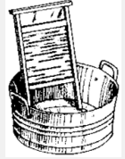 | Name_________________  Date__________________  Tutors! Adults! Help this young chemist by visiting http:genest.weebly.com with any smart phone

- Using your algebra skills rearrange Q = (m) (C) (∆T) to isolate the indicated variable in each case (isolate means ‘get it on one side of the equals sign by itself).
Isolate C | Isolate ∆T

- How much heat is absorbed by 20g granite boulder as energy from the sun causes its temperature to change from 10°C to 29°C? (Specific heat capacity of granite is 0.1 cal/gºC)

- How much heat is released when 30 g of water at 96°C cools to 25°C? The specific heat of water is 1 cal/g°C.

- Decide whether heating (we called it Q) is entering or leaving the object in bold..
a) An ice cube is placed in a cup of hot coffee
An ice cube is placed in a cup of hot coffee
b) A pot of hot tea is sealed into a well-insulated thermos
c) Some cold cream is poured into a cup of hot coffee
d) You blow air across a bowl of hot soup
e) You jump into an ice cold pond

- How much heat will raise a pot of 800 g of water from 20 °C to 90 °C?

- What happens when you place two objects at different temperatures in contact with each other?

- The temperature of a sample of metal with a mass of 10.0 g changed from 50.4°C to 25.0°C with the release of 95.1 joules of heat. What is the specific heat of this metal ?

- A 4.50 g coin of copper absorbed 54 calories of heat. What was the final temperature of the copper if the initial temperature was 25°C? The specific heat of copper is 0.092 cal/g°C.

- How much heat will raise a pot of 800 g of water from 20 °C to 90 °C? first find T

- What is the specific heat of silicon if it takes 192J to raise the temperature of 45.0g of Si by 6.0ºC?

- Make an energy diagram: Some water you spilled on your shirt evaporates.
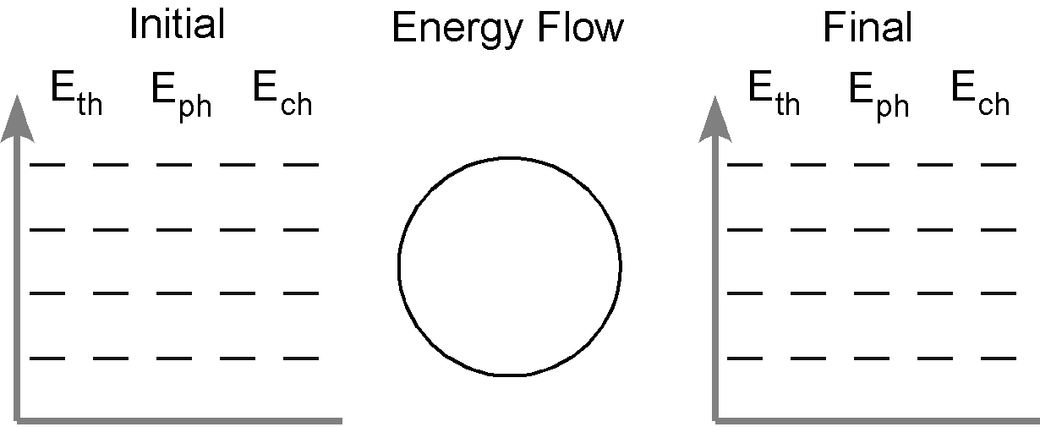

- Find the melting and boiling point of Bromine in the CRC Book in class or on Wikipedia at home. Write those two numbers in appropriate places on the Y-Axis.  - In each line below, mark a letter to describe what phase is present.  ______ pure liquid ______ mix of gas and liquid  ______ pure solid ______ mix of liquid and solid  ______ pure gas |  | 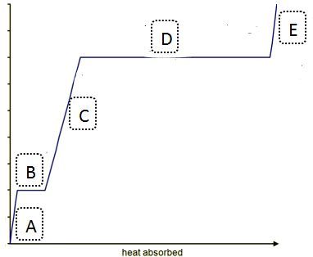

- The graph below left represents the heating curve for helium being heated from liquid state to a temperature above its boiling point.
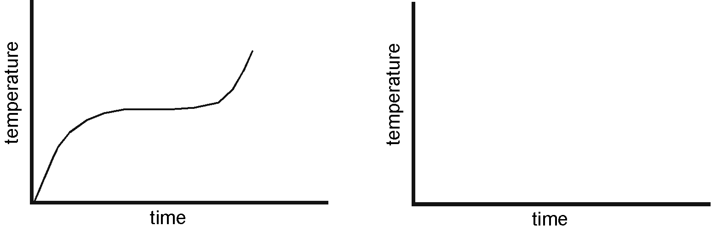
- Sketch the heating curve for a larger sample of the same liquid.
- Put little P’s all along the line of this graph if it is a time when the helium is gaining mostly potential energy
- Draw a circle around the part of the graph where you think E_{th} is increasing. Label it E_{th}

- Find the melting and boiling point of Aluminum in Table S and label the Y-axis of the graph at right with those two numbers.
In each line below,circle the correct choice to describe how the motion of the atoms is changing.
- {atoms moving faster / atom position becomes farther apart}
- {atoms moving faster / atom position becomes farther apart}
- {atoms moving faster / atom position becomes farther apart}
- {atoms moving faster / atom position becomes farther apart}
- {atoms moving faster / atom position becomes farther apart}

- Which scientist improved the thermometer by filling it with mercury to make it smaller and portable so doctors could use it to take the temperature of a patient? (See the website for advice on how to get movie notes from the movie we watched. . .)

  - Faraday
  - Celsius
  - Fahrenheit
  - Rumford

