Review #1 For Thursday’s Test  CλeMis+ry: http://genest.weebly.com  Stop in for help every day at lunch and Tues, Weds this week after school! | 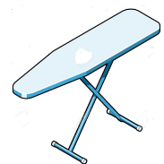 | Name_____________  Period_____________

- Convert 45,000 joules into Calories (spelled with a capital). [useful numbers for this are in your notebook or the top of the next page of this handout]]

- In today’s lecture we dropped metal into water. The water went temperature went from ____ °C to ____ °C. The mass of the water was ________ grams. We know that the Cp of water (using joules) is ________ (including units).
Calculate the amount of heat that entered the water.

The following situations all were shown during lecture in class today. In each case, the system has been underlined in the description.
- Dropping hot aluminum into cold water | Choose the ONE part of the heating curve best fits the situation described at left?  ( A to B ) ( B to A ) (B to C )  ( C to B ) ( C to D ) ( D to C) (D to E) (E to D ) (E to F ) ( F to E)  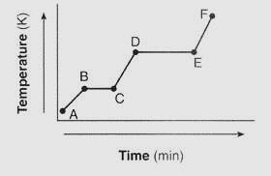 | Fill in the energy diagram. Don’t forget to write a word in the circle to define what the system is. 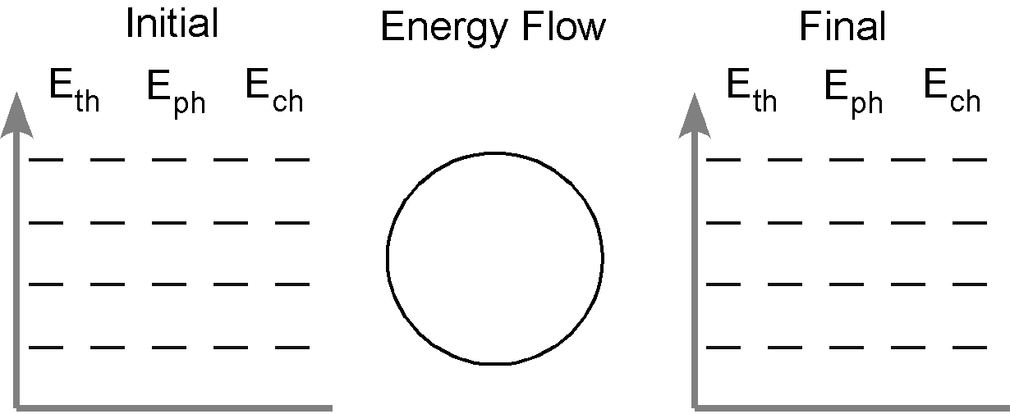

- Dropping hot aluminum into cold water | Choose the ONE part of the heating curve best fits the situation described at left?  ( A to B ) ( B to A ) (B to C )  ( C to B ) ( C to D ) ( D to C)  (D to E) (E to D ) (E to F ) ( F to E) | Fill in the energy diagram. Don’t forget to write a word in the circle to define what the system is.

You will always be given these numbers on tests and quizzes.
4.184 kilojoules = 4184 joules = 1000 calories = 1 Calorie

- In today’s lecture we dropped metal into water. The heat that entered the water was calculated in Question #1, above, to be ____________ J. The heat that left the aluminum must therefore* be ________J. The mass of the aluminum was ______ grams. From looking up the specific heat, we know that Cp for aluminum is always ________________(don’t forget units).
Calculate the ∆T for the Aluminum.

* It is safe to assume that all of the joules gained by the water were lost by the hot aluminum, according to the Law of Conservation of Energy

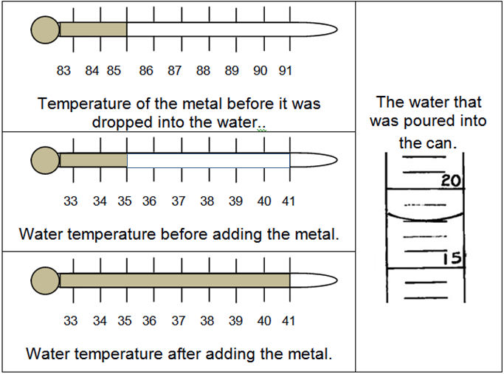 | - Stop. Read the four images at the left. They describe data for dropping hot metal into water. Use Q = m C_{p} ∆T to calculate how much heat entered the water.  - How much heat left the metal?

- If the metal in the preceding two questions above had a mass of 24 grams, calculate the Cp of the metal.

- Convert 123 cal into J.

For each item below indicate whether it applies to HEAT or TEMPERATURE
- _____ Can be measured by inserting a thermometer
- _____ Can be measured by holding water nearby and then multiplying mass_{water} x Cp_{water} x ΔT_{water}
- _____ one common unit for measuring this is degrees celsius
- _____ one common unit for measuring this is kelvins
- _____ one common unit for measuring this is joules
- Convert 123 calories into Calories.

- Which contains more energy? ( 1 Calorie / 1 calorie )

- Which contains more energy? ( 1 joule / 1 calorie )

- If a 3.1g ring made of unknown metal is heated using 10.0 calories, its temperature rises 17.9°C. Calculate the specific heat of the ring.

- A can of cold soda warms as it is left on the counter.
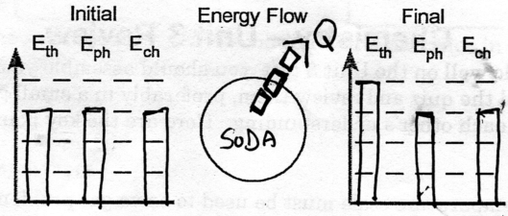
List two mistakes in the energy diagram shown above

- ______________________________________________________________

- ______________________________________________________________
- A gas filled weather balloon with a volume of 30.0 L is released at sea level at 100.1 kPa and 18.0°C. Find the volume the balloon will be at maximum altitude where the temperature is 241.0 kelvins and the pressure is 0.604 atm.

