Review #2  CλeMis+ry: http://genest.weebly.com  Stop in for help every day at lunch and Tues, Weds., &Thurs after school! | 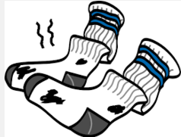 | Name_____________  Period_____________

The following numbers will be available on all tests and quizzes:
760. torr = 760. mmHg = 1.00 atm = 101.3 kPa = 101,300 pascals = 14.7 p.s.i.
4.184 kilojoules = 4184 joules = 1000 calories = 1 Calorie

- Look at the bottom. Copy those eight labels into the correct blanks on this cooling curve. | 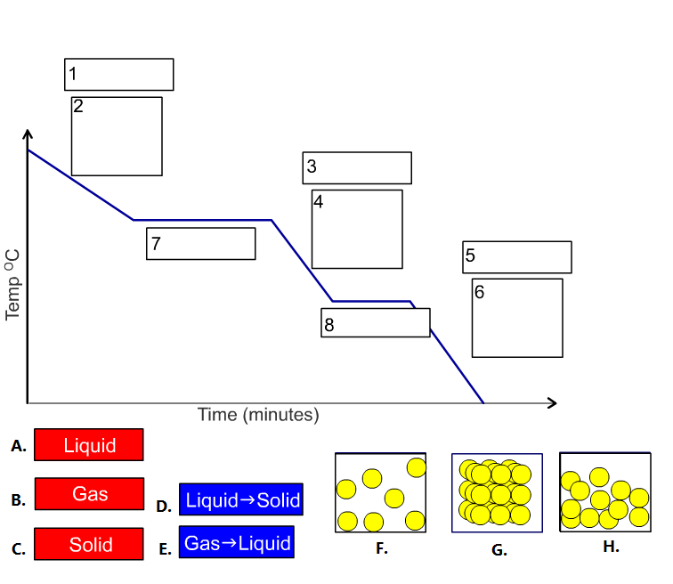

- Q=mc ΔT Type Problems
For the formula Q=m C_{p} ΔT fill in the parentheses at right with the words such as “change of temperature”, “heat”, “specific heat”, and “mass” | ( ) = ( ) ( ) ( )

For the formula Q=m C_{p} ΔT fill in the parentheses at right with the units that go in Q = m C , such as “grams”, “joules”, “°C”, and $\frac{joules}{g·°C}$ | [ ] = [ ] [ ] [ ]

- In a container of gas, when temperature decreases pressure usually ( decreases / increases ).
- In a container of gas, when number of particles decreases pressure usually ( decreases / increases ).
- In a container of gas, when volume decreases pressure usually ( decreases / increases ).

- Read the problem below and then just check one box (don’t do any math):  □ pressure will decrease  □ pressure will increase |  | - Read the problem below and then just check one box (don’t do any math):  □ pressure will decrease  □ pressure will increase
A krypton balloon contains 5,000,000 atoms of krypton at 77.111 kPa pressure. If more krypton atoms are added until there are 7,000,000 atoms in the balloon what will happen to the pressure? |  | A sample of ethane gas has a volume of 125 mL at 725 torr. If the volume is changed to 100 mL what will happen to the pressure?

- Read the problem below and then just check one box (don’t do any math):  □ pressure will decrease  □ pressure will increase |  | - Read the problem below and then just check one box (don’t do any math):  □ pressure will decrease  □ pressure will increase
A copper container has a volume of 555 mL and is filled with air at 298K. The container is immersed in dry ice. How will the pressure change? |  | When air in a steel cylinder is compressed from 10 L to 5 L, and temperature remains constant, what will happen to the gas pressure inside the cylinder?

- Standard Pressure: _______ kPa
- Standard Pressure: _______ atm
- Standard Temperature_______ K
- Standard Temperature_______°C
- Decide whether heating (we called it Q) is entering or leaving the object in bold..
a) ________________At night, the blanket is too short so your feet are sticking out into the chilly air of your bedroom
b) ________________A cat is curled up sleeping in a beam of sunlight
c) ________________You shake your hand with Principal Hernandez and his hand feels warm.

- Which of these units are suitable for solving gas math problems?
  - kelvins are (suitable / not suitable )
  - degrees celsius are (suitable / not suitable )

- The temperature of a sample of aluminum increases from 24.5°C to 46.6°C as it absorbs 5650 calories of heat. What is the mass of the aluminum? (page 297 of our text says the spec heat of Aluminum is 0.21 cal/g°C))

- A pan of water (25˚C) is heated to boiling and some of the water is boiled away. Do separate energy bar charts for each stage of the process.
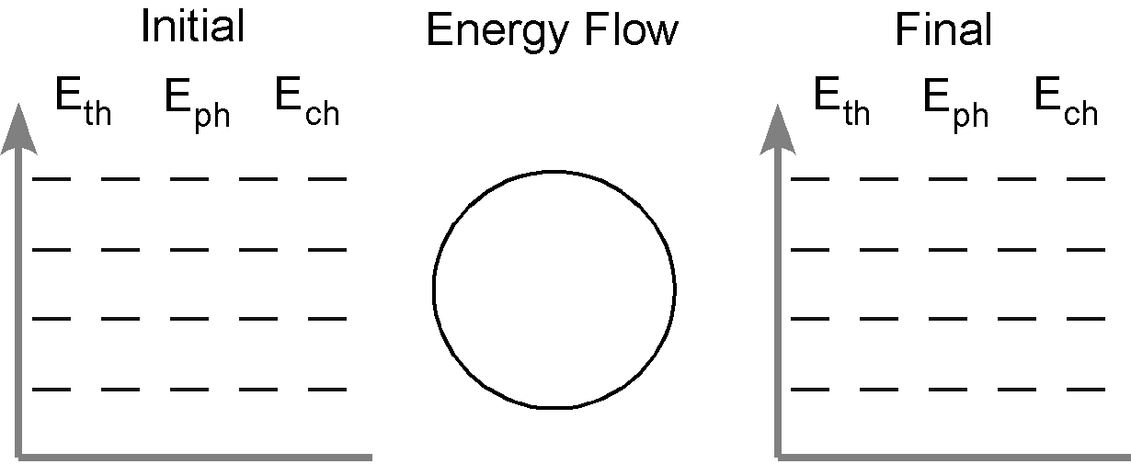

Fill in blank with whichever is more appropriate, 'specific heat' or 'heat'
- ___________ Q stands for this in the formula Q=m C ΔT.
- ___________ C stands for this in the formula Q=m C ΔT
- ___________This is a constant number for a given substance.
- ___________This is sometimes measured in joules
- ___________This is sometimes measured in $\frac{J}{g·°C}$
- ___________This is sometimes measured in calories

- A sample of ethane gas has a volume of 125 mL at 725 torr. If the volume is changed to 100 mL what will be the new pressure?

- A krypton balloon contains 5,000,000 atoms of krypton at 77.111 kPa pressure. If more krypton atoms are added until there are 7,000,000 atoms in the balloon what will be the new pressure (in kPa)?

Show work for full credit.

- If 15 grams of metal were dropped into 11 grams of water calculate the following
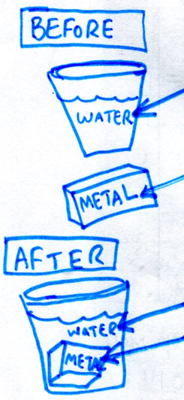 | 14°C water  101°C metal  43°C water  43°C metal | - Find ∆T for the water.  - How many joules of heat entered the water?  - How many joules of heat heat left the metal?
- Calculate the specific heat of the metal

- Write each number in standard decimal style, without an exponent
5.28x10⁻⁴

2.000x10⁵

- Write each number in scientific notation
0.0003434

440000000

- write the answer to the correct number of significant figures
=
- write the answer to the correct number of significant figures
=

- Convert 45,000 joules into Calories (spelled with a capital).

- A gas occupies a volume of 750 mL at 0ºC. The conditions are changed to 500mL at 2.0 atm and 25ºC. What was the original pressure?

- A gas occupies a volume of 2.5 L at 600 mm Hg and 22ºC. What is the new temperature if conditions are changed to 760 mm Hg and 1.8 L?

- Fluorine gas at 300K occupies a volume of 500 mL. To what temperature should it be lowered to bring the volume to 300 mL?

- A sample of carbon dioxide occupies a volume of 3.50 liters at 125 kPa pressure. What pressure would the gas exert if the volume was decreases to 2.00 liters?

For each item below indicate whether it applies to HEAT or TEMPERATURE
- _____ Can be measured by inserting a thermometer
- _____ Can be measured by holding water nearby and then multiplying mass_{water} x Cp_{water} x ΔT_{water}

- _____ one common unit for measuring this is degrees celsius
- _____ one common unit for measuring this is kelvins
- _____ one common unit for measuring this is joules

M

