energy storage & transfer  East.H.S. ©λ€M|5+rγ  visit http://genest.weebly.com | R. Williams by Omar Momani | Name_________________  Date__________________  Come for assistance and cheerful encouragement after school Tues, Thurs, or every day at lunch

- Heating is a form of ( energy storage / energy transfer )
- E_{th} is a form of ( energy storage / energy transfer )
- E_{ch} is a form of ( energy storage / energy transfer )
- Radiating is a form of ( energy storage / energy transfer )
- Complete the description by circling the best choice. E_{ph} is…
  - a way to store energy
  - a way for energy to enter or leave an object
- Pushing (working) is a form of ( energy storage / energy transfer )
  - a way to store energy
  - a way for energy to enter or leave an object

You will always be given these numbers on tests and quizzes.
0 degrees C = 273 kelvins
760. torr = 760. mmHg = 1.00 atm = 101 kPa = 101,300 pascals = 14.7 p.s.i.
R = 0.0821 liter-atm/mol-K (for PV=nRT problems, if you use this R value you must use these units)
1.00 mole of things is 6.02x10²³ things.

Conversions practice
- Your best friend gives you 0.00000044 moles of gummi worms. How many worms is this?

- The pressure in a certain bike tire is 77.0 psi. How many kilopascals is this?

- What is Standard Pressure in kilopascals?

- If a scuba diver has 23,000 mmHg pressure in her air tank, what is the pressure in atm?

- If a squirrel caches 235 acorns under an oak tree, how many moles of acorns does the squirrel have?

- A small silver coin could have 3.06x10²⁴ atoms of silver. How many moles of silver atoms is this?

- American pennies contain about 0.0393 moles of copper. How many atoms is this?

Match the name with the description of the scientist.

- ______ Wrongly thought heat was a fluid called ‘caloric’ [Oops!]
- ______ Moving objects can create heat; E_{kinetic} can freely convert into E_{th}
- ______ Adding salt to -3°C ice melts it to -7°C water (which shows E_{ph} exists)
- ______ Evidence that temperature isn’t caused by an invisible substance: showed the weight of frozen water is the same as weight of same water when liquid.
- ______ Evidence that temperature isn’t caused by an invisible substance: showed that a nearly infinite amount of heat can come out of a cannon as you grind the metal.

- Rumford
- Joule
- Lavoissier
- Boyle
- Drebbel

- For a girl peddling a bike, show arrows with Q, R, and/or W coming in and out of the circle. Show bar graphs for before and after. A girl peddling a bike.
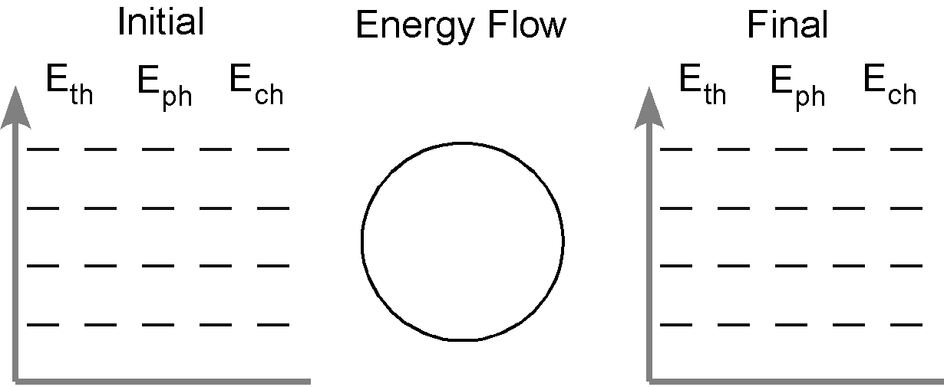
- A water molecule in a microwave

- At what temperature will 5.00mol of Cl₂ exert a pressure of 900 torr at a volume of 750 mL? **fix the units first! They must match the units of your “R”.

- How many moles of nitrogen gas will occupy a volume of 347 mL at 6.680 kPa and 27ºC?

