Sadf\
LAB REPORT
Freezing Lab
Sad

- Write the name of the substance we will melt today __________.

- Prediction: Circle how you think the temperature will change as we let the hot liquid cool off and turn into a solid:
This? This? This? This? Or draw your own!
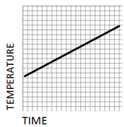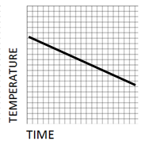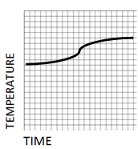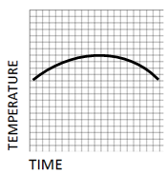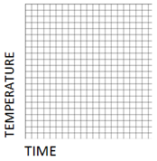
- Temperature and time are [circle one](inversely* / directly * ) related.
[*Inversely means, when one grows the other shrinks. Directly means, when one grows, the other grows.]

- In a boiling water bath, clamp your stearic acid + thermometer + test tube. Keep the Bunsen Burner going until the Stearic Acid reaches 75°C and is transparent..
- Turn off the burner. Ask the teacher to help you lower your water bath.. Leave the tube in its clamp, cooling in the air.
- In the table below, record the temperature of the stearic acid every 20 seconds in this table until it reaches 45°C.

Seconds | Temp (°C) |  | Seconds | Temp (°C) |  | Seconds | Temp (°C) |  | Seconds | Temp (°C) |  | Seconds | Temp (°C)
0 |  |  | 200 |  |  | 400 |  |  | 600 |  |  | 800
20 |  |  | 220 |  |  | 420 |  |  | 620 |  |  | 820
40 |  |  | 240 |  |  | 440 |  |  | 640 |  |  | 840
60 |  |  | 260 |  |  | 460 |  |  | 660 |  |  | 860
80 |  |  | 280 |  |  | 480 |  |  | 680 |  |  | 880
100 |  |  | 300 |  |  | 500 |  |  | 700 |  |  | 900
120 |  |  | 320 |  |  | 520 |  |  | 720 |  |  | 920
140 |  |  | 340 |  |  | 540 |  |  | 740 |  |  | 940
160 |  |  | 360 |  |  | 560 |  |  | 760 |  |  | 960
180 |  |  | 380 |  |  | 580 |  |  | 780 |  |  | 980
- Estimate what the freezing point is of your substance_____________°C
- What is the melting point of your substance?_____________ °C
- From the book at the front of the room, obtain the accepted melting point of STEARIC ACID. Record it here:________
- Is your answer in #11 too low or too high?

Homework: Graph your data from the front side. For full credit, each data point should be either an X or a dot with a square around it. The numbers on your axes should be written clearly. Your scale should spread the data out so it is not scrunched up.
TEMPERATURE (°C)
TIME (SECONDS)

- Based on your cooling graph, draw below a crude guess for the shape of a graph for heating stearic acid from 45°C to 75°C.

