Energy and Phase Change  East.H.S. ©λ€M|5+rγ  visit http://genest.weebly.com | 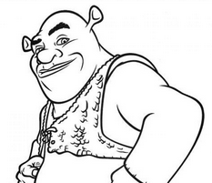 | Name_________________  Date__________________  The test is this Friday. What’s on it? See the class website.

Complete the energy diagrams in the way we did in class.

Example:
Draw bar graphs and an arrow and circle to describe the energetic changes for a cup of hot coffee, sitting on a table.
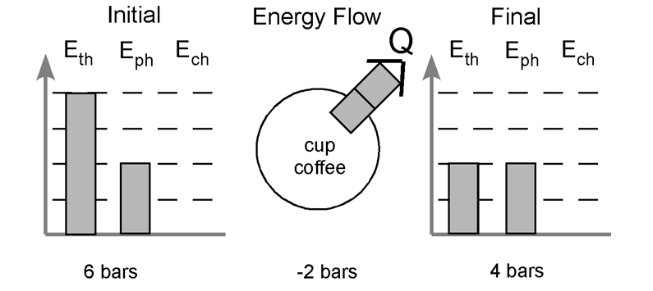 | (Notice that the number of squares in circle arrow matches the number of squares coming or going between the two bar graphs)
initial: |  | final:

1. Some water you spilled on your shirt evaporates.
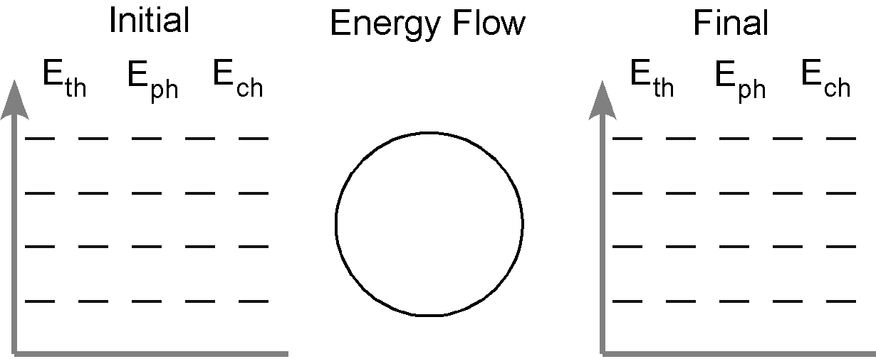
In words and/or drawings describe how the arrangement and motion of the molecules change from the initial to the final state:

initial: |  | final:

2. Water vapor in the room condenses on a cold surface
In words and/or drawings describe how the arrangement and motion of the molecules change from the initial to the final state:

initial: |  | final:

3. A pan of water (25˚C) is heated to boiling and some of the water is boiled away. Do separate energy bar charts for each stage of the process.
In words and/or drawings describe how the arrangement and motion of the molecules change from the initial to the final state:

initial: |  | final:

