East.H.S. ©λ€M|5+rγ  visit http://genest.weebly.com | 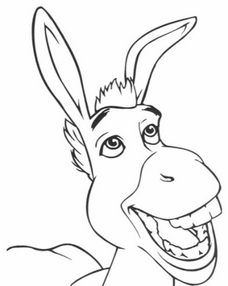 | Name_________________  Date__________________  The test is this Friday. What’s on it? See the class website.

1. A cup of hot coffee cools as it sits on the table.
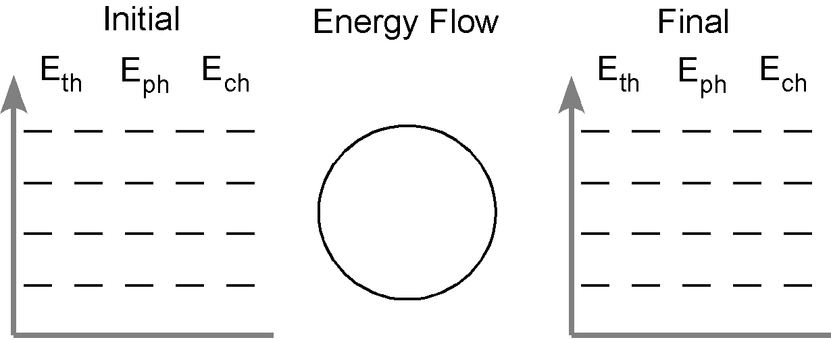
In words and/or drawings describe how the arrangement and motion of the molecules change from the initial to the final state:

initial: |  | final:

2. A can of cold soda warms as it is left on the counter.

In words and/or drawings describe how the arrangement and motion of the molecules change from the initial to the final state:

initial: |  | final:

3. A tray of water (20 ˚C) is placed in the freezer and turns into ice cubes (- 8 ˚C)

In words and/or drawings describe how the arrangement and motion of the molecules change from the initial to the final state:

initial: |  | final:

4. Where does the energy that leaves the system in #3 go? How does this energy transfer affect the room temperature in the kitchen? Do you have any experience that supports your answer?

5. One of the ice cubes described in #3 is placed in a glass of room temperature (25 ˚C) soft drink. Do separate bar charts for the ice cube and the soft drink.
Describe how the arrangement and the motion of the particles in each system change from the initial to the final state.

