Review #2  East.H.S. ©λ€M|5+rγ  visit http://genest.weebly.com | 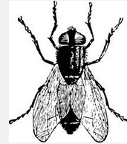 | Name_________________  Date__________________  The test is this Friday. What’s on it? See the class website.

- A can of cold soda warms as it is left on the counter.
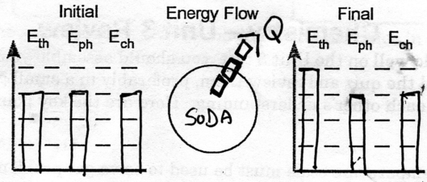
List one or more mistakes in the solution shown above

- A tray of water (20 ˚C) is placed in the freezer and turns into ice cubes (- 8 ˚C)
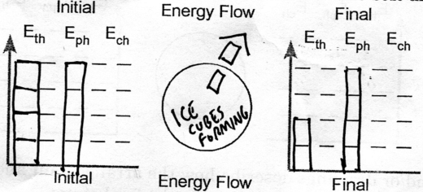
List one or more mistakes in the solution shown above

- Describe what early chemists meant by caloric

- We describe three storage “accounts” to understand the changes we see in chemistry. State their names and describe how energy is stored in these three storage modes

- What is our more modern word for caloric? ___________
- What did James Joule discover about energy?

You will always be given these numbers on tests and quizzes.
0 degrees C = 273 kelvins
760. torr = 760. mmHg = 1.00 atm = 101 kPa = 101,300 pascals = 14.7 p.s.i.
R = 0.0821 liter-atm/mol-K (for PV=nRT problems, if you use this R value you must use these units)
1.00 mole of things is 6.02x10²³ things.

This is a before and after problem. Your solution should be a ‘lonely number’ followed by one or more ratios.
- A quantity of gas exerts a pressure of 98.6 kPa at a at a temperature of 22.0 °C. If the volume remains unchanged, what pressure will it exert at -8.0°C?

This is a now problem. Your solution should start by writing PV=nRT and then rearranging the letters to get the unknown alone.
Your units must be the same as whatever units your ‘R” is in.
- A 280.0 mL sample of neon exerts a pressure of 660.0 torr at 26.0°C. How many moles does it contain?
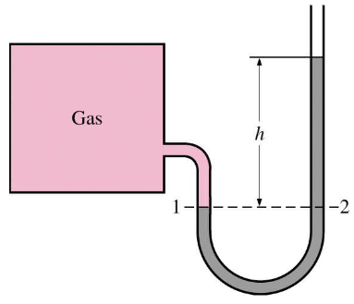
- In a container of gas, when volume decreases pressure usually ( decreases / increases ).

- If this manometer is in a room with 742 mmHg ambient pressure, and “h” is 11.0 millimeters of mercury the pressure of the gas inside the square box is ___________

- If gas in this box is at a pressure of 790 torr and the height of the mercury shown by h is 13 mm, the ambient pressure in the room must be __________
- How many atoms are in 0.66 moles of calcium atoms?

What else should you review? Review the original notes and worksheets. And practice more math problems!

