potential energy vs kinetic energy  East.H.S. ©λ€M|5+rγ  visit http://genest.weebly.com |  | Name_________________  Date__________________  Come for assistance and cheerful encouragement after school Tues, Thurs, every day at lunch

- An object has energy if it can push a second object and make it move. Use your imagination to tell what could get pushed by each of these forms of energy.
Object | Type of energy | How could it push something? (Be imaginative. There are no pre-determined "correct" answers.)
A book on a high shelf | □ kinetic  □ potential
steam from a kettle | □ kinetic  □ potential
A little pile of gunpowder. | □ kinetic  □ potential
Mercury expanding | □ kinetic  □ potential
loud, loud sound from a trumpet | □ kinetic  □ potential
A book on the floor of our classroom | □ kinetic  □ potential
a Snickers ™ bar with almonds | □ kinetic  □ potential
Getting energy by eating candy | □ kinetic  □ potential

- Convert the following to normal numbers
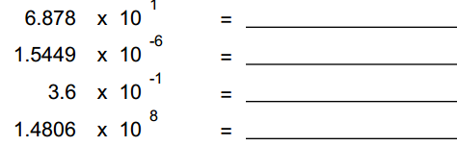
- write the answer to the correct number of significant figures
=
- write the answer to the correct number of significant figures
=

- Here's a fellow with a powerful rolling electrical sound system that makes the air vibrate with sound waves. Try to list a total of eight forms of energy in this system. Divide the energy that you list into Kinetic Energy and Potential Energy (hint: think in terms of electrical energy ,heat, chemical energy, moving particles, light energy, etc)  kinetic energy potential energy | 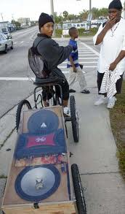

For each pair of quantities mark < , =, or >.
Example: | U.S. Deaths due to bicycle accidents | __>__ | U.S. Deaths due to Ebola

 | - The temperature of 300°C water | ________ | The temperature of 300K water

 | - The mass of a 300 μg object | ________ | The mass of a 300 ng object

 | - 6.878 x 10¹ | ________ | 9.4608 x 10⁻⁶

 | - The value of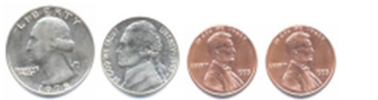 | _____ | The value of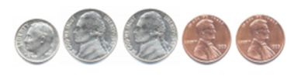

- For the following sample data, is the value V/T growing, shrinking, or a constant value?

- For the following graph, what value did the student obtain for "absolute zero"? | - For the following graph, what value did the student obtain for "absolute zero"?

