BETWEEN THE TRUTH AND A LIE!  East.H.S. ©λ€M|5+rγ  visit http://genest.weebly.com | 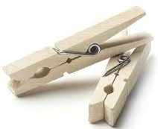 | Name_________________  Date__________________  Come for assistance and cheerful encouragement after school Tues, Thurs, or every day at lunch

Here are a bunch of helpful numbers and figures
0 degrees C = 273 kelvins 760. torr = 760. mmHg = 1.00 atm = 101.3 kPa = 101,300 pascals

Unit conversion.
Convert each of these by writing a starter number, a goal unit, and the numbers in a relationship.

- If the pressure during a Mexican Hurricane was 797 mmHg, what would the pressure be in kPa?

- If the pressure of a bike tire was 7.6x10⁶ pascals, what would the pressure be in atm?
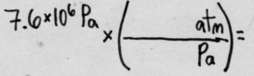
- In a container of gas, when temperature increases pressure usually ( decreases / increases ).
- In a container of gas, when number of particles increases pressure usually ( decreases / increases ).
- In a container of gas, when volume increases pressure usually ( decreases / increases ).
- Which of these units are suitable for solving gas math problems?

  - kelvins are (suitable / not suitable )
  - degrees celsius are (suitable / not suitable )

- Read the problem below and then check one box  □ pressure will decrease  □ pressure will increase | Only one of these is correct. Only calculate the answer for that one  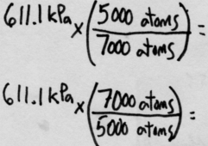
A tiny steel tank of gas contains 5,000atoms of krypton at 611.1 kPa pressure. If more krypton atoms are added until there are 7,000atoms in the balloon what will be the final pressure?

- ead the problem below and then check one box  □ volume will decrease  □ volume will increase | Only one of these is correct. Only calculate the answer for that one  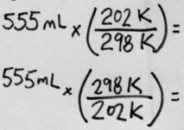
A copper container has a volume of 555 mL and is filled with air at 298K. The container is immersed in a dry ice bath at 202K. What will be the final volume?

- Read the problem below and then check one box  □ pressure will decrease  □ pressure will increase | Only one of these is correct. Only calculate the answer for that one  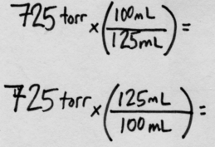
A sample of ethane gas has a volume of 125 mL at 725 torr. If the volume is changed to 100 mL what will be the new pressure?

- Read the problem below and then check one box  □ pressure will decrease  □ pressure will increase | Only one of these is correct. Only calculate the answer for that one  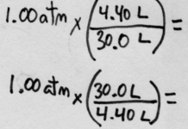
If air at Standard Pressure in a steel cylinder is compressed from 30.0 L to 4.40 L, and temperature remains constant, what will be the new gas pressure inside the cylinder?

Unit conversion. Convert each of these by writing a starter number, a goal unit, and the numbers in a relationship.

If the pressure outside of a submarine was 11.4 atm, what would the pressure be in torr?

If the pressure outside on an exoplanet was 66.5 pascals, what would the pressure be in atm?

- Read the problem below and then check one box  □ volume will decrease  □ volume will increase | Only one of these is correct. Only calculate the answer for that one  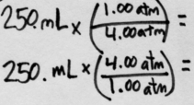
What volume will 250. mL of gas at STP occupy if the pressure changes to 4.00 atmospheres?

- Read the problem below and then check one box  □ volume will decrease  □ volume will increase | Only one of these is correct. Only calculate the answer for that one  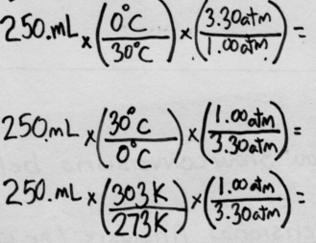
What volume will 250. mL of gas at STP occupy if the temperature changes to 30°C and pressure to 3.30atm?

- Read the problem below and then check one box  □ pressure will decrease  □ pressure will increase | Only one of these is correct. Only calculate the answer for that one  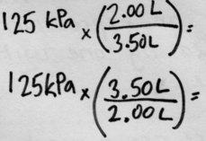
A sample of carbon dioxide occupies a volume of 3.50 liters at 125 kPa pressure. What pressure would the gas exert if the volume was decreases to 2.00 liters?

- Read the problem below and then check one box  □ pressure will decrease  □ pressure will increase | Set up and solve.
A 2.0 liter container of nitrogen has a pressure of 3.2 atm. What volume would be necessary to decrease the pressure to Standard Pressure?

- Read the problem below and then check one box  □ volume will decrease  □ volume will increase | Set up and solve.
A sample of nitrogen occupies a volume of 250. mL at 95ºC. What volume will it occupy at 0ºC? Be careful of your temperature units!

