manometers and barometers  East.H.S. ©λ€M|5+rγ  visit http://genest.weebly.com |  | Name_________________  Date__________________  Come for assistance and cheerful encouragement after school Tues, Thurs, every day at lunch

- For the following graph, what value did the student obtain for "absolute zero"? | - For the following graph, what value did the student obtain for "absolute zero"?
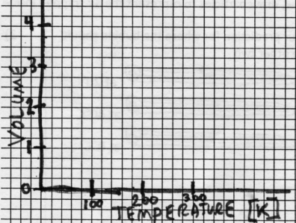
- What temperature is Absolute Zero supposed to always be? ________ kelvins or ______ °C
- What special thing happens to matter at Absolute Zero? _______________________________
- Which of the following is not standard pressure?

a. 1 atm b. 740 mm Hg c. 101.3 kPa d. 101300 Pa e. none

- The temperature at which all vibration (“The Dance”) stops is (circle one or moreI choices)
a. 0 °C b. -273 K c. 0 K d. 273 °C e. -273°C

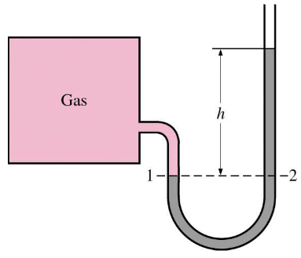
- If this manometer and box contained 2x10²² atoms of helium and then you added another 2x10²² atoms of helium, the height of liquid shown by “h” would
  - decrease
  - stay the same
  - increase

- If the picture of this manometer and box was taken in a room in Madison (elevation 800 feet) but the box was later moved to Boulder, Colorado (useful elevation data is at the top of this page…) the height of liquid shown by “h” would
- decrease
- stay the same
- increase

\
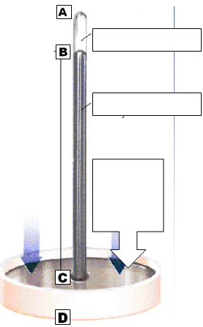 | - Write these labels into the appropriate boxes of the diagram to the left:  - the atmosphere presses here  - pure mercury liquid  - vacuum  - The distance from A to B is  - meaningless and useless  - always 760 millimeters long at sea level on an average day  - The distance from B to C is  - meaningless and useless  - always 760 millimeters long at sea level on an average day  - The distance from C to D is  - meaningless and useless  - always 760 millimeters long at sea level on an average day

- 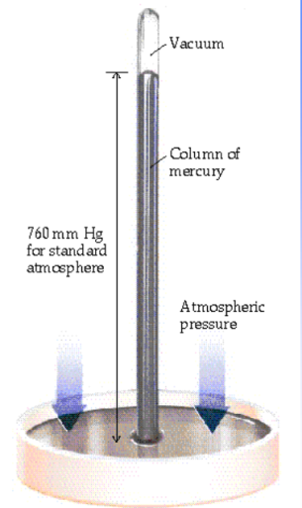 Redraw how the liquid height would look different if … | - …if the weather caused a low pressure system in the area | - …if a liquid of less density were substituted for the mercury | - …if instead of a vacuum there was a small amount of air int he top of the tube | - …if the tube were open at the top instead of closed

- If this manometer is in a room that is at standard pressure, and “h” is 7.0 millimeters of mercury the pressure of the gas inside the square box is ___________

- If gas in this box is at a pressure of 751 torr and the height of the mercury shown byt h is 13 mm , the ambient pressure in the room must be __________
If this manometer and box are in a room in Madison (elevation 800 feet) and they are moved to Poughkeepsie, New York (elevation 60 feet) the height of liquid shown by “h” would
  - decrease
  - stay the same
  - increase
- If this manometer and box are in our chemistry room and are moved out to the student parking lot the height of liquid shown by “h” would
  - decrease
  - stay the same
  - increase
- If this manometer and box contained 30 mL of gas at standard temperature and then the temperature of the gas were changed to 250 kelvins, the height of liquid shown by “h” would
  - decrease
  - stay the same
  - increase
- If this manometer and box contained 5x10²² atoms of helium and then you added another 2x10²² atoms of helium, the height of liquid shown by “h” would
  - decrease
  - stay the same
  - increase
- Convert 652.5 mmHg (lowest pressure ever recorded at sea level—inside Typhoon Tip) to
  - torr
  - atm
  - kPa

- A sealed-tube manometer as shown below, left, has a complete vacuum. The liquid mercury levels in both arms of the U-tube are equal. If a gas sample is introduced into the round flask, the mercury levels are different, as shown on the right.
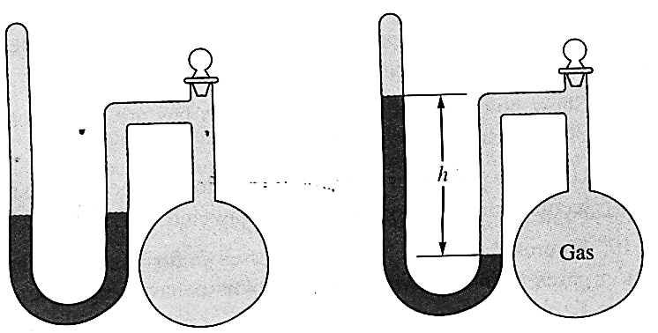
The difference h is the measure of the pressure of the gas inside the flask. If h is equal to 6.5 cm, calculate the pressure in the flask in the following units:
- mmHg  - torr | - pascals  - atmospheres

- A diagram for an open tube manometer is shown in Figure A; the flask is open to the atmosphere, the mercury levels are equal. In Figure B, a gas is now contained in the flask. Calculate the pressure in the flask in the four units given below. |  | 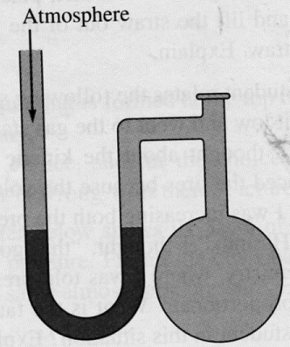  A | B
- mmHg  - torr | - pascals  - atmospheres

