solving gas math using a table  East.H.S. ©λ€M|5+rγ  visit http://genest.weebly.com | 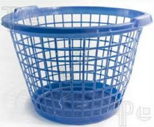 | Name_________________  Date__________________  Come for assistance and cheerful encouragement after school Tues, Thurs, or every day at lunch

On each of the problems below, start with the given P, V, T, or n; then make a decision as to how a change in P, V, T, or n will affect the starting quantity, and then multiply by the appropriate factor. Draw particle diagrams of the initial and final conditions.
1. A sample of gas occupies 150 mL at 25 ˚C. What is its volume when the temperature is increased to 50˚C? (P and n = constant)
 | P | T | V | n | Write goal in all three boxes of the appropriate column  Write numbers for any ‘before’ and ‘after’ numbers  Write ‘increase’ , ‘decrease’, or ‘no effect’ in the bottom box
Initial
Final
Effect on the goal

2. The pressure in a bicycle tire is 105 psi at 25˚C in Fresno. You take the bicycle up to Huntington, where the temperature is – 5˚C. What is the pressure in the tire?
(V and n = constant)
 | P | T | V | n | Write goal in all three boxes of the appropriate column  Write numbers for any ‘before’ and ‘after’ numbers  Write ‘increase’ , ‘decrease’, or ‘no effect’ in the bottom box
Initial
Final
Effect on the goal

3. What would be the new pressure if 250 cm3 of gas at standard pressure is compressed to a volume of 150 cm3 ?
 | P | T | V | n
Initial
Final
Effect

4. What would be the new volume if 250 cm3 of gas at 25˚C and 730 mm pressure were changed to standard conditions of temperature and pressure?
 | P | T | V | n
Initial
Final
Effect

5. Sam’s bike tire contains 15 units of air particles and has a volume of 160mL. Under these conditions the pressure reads 13 psi. The tire develops a leak. Now it contains 10 units of air and has contracted to a volume of 150mL). What would the tire pressure be now?

 | P | T | V | n
Initial
Final
Effect

6. A closed flask of air (0.250L) contains 5.0 “puffs” of particles. The pressure probe on the flask reads 93 kPa. A student uses a syringe to add an additional 3.0 “puffs” of air through the stopper. Find the new pressure inside the flask.
 | P | T | V | n
Initial
Final
Effect

7. A 350 mL sample of gas has a temperature of 30˚C and a pressure of 1.20 atm. What temperature would be needed for the same amount of gas to fit into a 250 mL flask at standard pressure?
 | P | T | V | n
Initial
Final
Effect

8. A 475 cm3 sample of gas at standard temperature and pressure is allowed to expand until it occupies a volume of 600. cm3. What temperature would be needed to return the gas to standard pressure?
 | P | T | V | n
Initial
Final
Effect

9. The diagram below left shows a box containing gas molecules at 25˚C and 1 atm pressure. The piston is free to move.
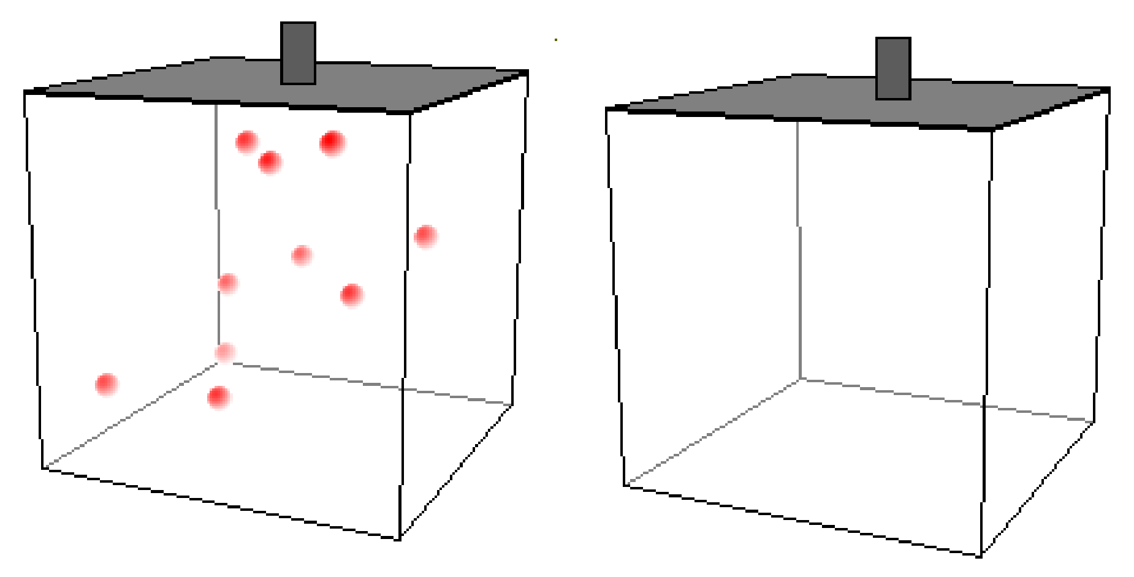
In the box at right, sketch the arrangement of molecules and the position of the piston at standard temperature and pressure. Does the volume decrease significantly? Why or why not?

