doing math with gas pressures  East.H.S. ©λ€M|5+rγ  visit http://genest.weebly.com | 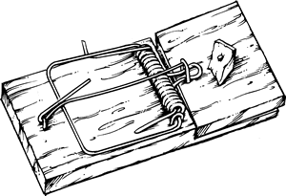 | Name_________________  Date__________________  Come for assistance and cheerful encouragement after school Tues, Thurs, or every day at lunch

Here are a bunch of helpful numbers and figures
0 degrees C = 273 kelvins 760. torr = 760. mmHg = 1.00 atm = 101 kPa = 101,300 pascals

- In a container of gas, when temperature decreases pressure usually ( decreases / increases ).
- In a container of gas, when number of particles decreases pressure usually ( decreases / increases ).
- In a container of gas, when volume decreases pressure usually ( decreases / increases ).
- Which of these units are suitable for solving gas math problems?

  - kelvins are (suitable / not suitable )
  - degrees celsius are (suitable / not suitable )

- Read the problem below and then just check one box (don’t do any math):  □ pressure will decrease  □ pressure will increase |  | - Read the problem below and then just check one box (don’t do any math):  □ pressure will decrease  □ pressure will increase
A krypton balloon contains 5,000,000 atoms of krypton at 77.111 kPa pressure. If more krypton atoms are added until there are 7,000,000 atoms in the balloon what will happen to the pressure? |  | A sample of ethane gas has a volume of 125 mL at 725 torr. If the volume is changed to 100 mL what will happen to the pressure?
- Read the problem below and then just check one box (don’t do any math):  □ pressure will decrease  □ pressure will increase |  | - Read the problem below and then just check one box (don’t do any math):  □ pressure will decrease  □ pressure will increase
A copper container has a volume of 555 mL and is filled with air at 298K. The container is immersed in dry ice. How will the pressure change? |  | When air in a steel cylinder is compressed from 10 L to 5 L, and temperature remains constant, what will happen to the gas pressure inside the cylinder?

- Set up and calculate an exact solution to the problem below. |  | - Set up and calculate an exact solution to the problem below.
A krypton balloon contains 5,000,000 atoms of krypton at 77.111 kPa pressure. If more krypton atoms are added until there are 7,000,000 atoms in the balloon what will be the new pressure (in kPa)? |  | A sample of ethane gas has a volume of 125 mL at 725 torr. If the volume is changed to 100 mL what will be the new pressure?

- 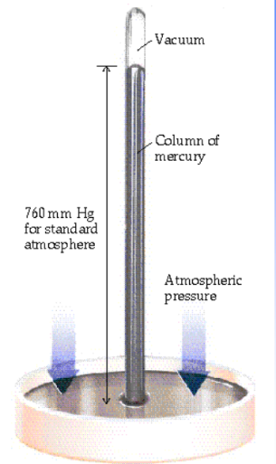 Redraw how the liquid height would look different if … | - …if a liquid of less density were substituted for the mercury | - …if instead of a vacuum there was a small amount of air int he top of the tube | - …if sunny weather caused a high pressure system in the area | - …if the mercury in the tube became much colder

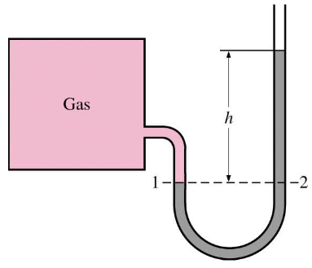
- If this manometer is in a room with 742 mmHg ambient pressure, and “h” is 11.0 millimeters of mercury the pressure of the gas inside the square box is ___________

- If gas in this box is at a pressure of 790 torr and the height of the mercury shown by h is 13 mm, the ambient pressure in the room must be __________
- If this manometer and box are in a room in Madison (elevation 800 feet) and they are moved to the highest point in Wisconsin the height of liquid shown by “h” would
  - decrease
  - stay the same
  - increase

- As shown below a manometer is connected at the right end to a sealed flask of gas and at the left end is open to the atmosphere. Calculate what the pressure of the gas in the flask is based on the numbers in the diagram.
 | - mmHg  - torr | - pascals  - atmospheres

