East.H.S. ©λ€M|5+rγ  visit http://genest.weebly.com | 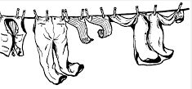 | Name_________________  Date__________________  This Friday is a tiny quiz  Thursday Nov 11 is a big Test  Friday Nov 12 there is no school for students

For each of the situations described below, use an energy bar chart to represent the ways that energy is stored in the system and flows into or out of the system. Below each diagram describe how the arrangement and motion of the particles change from the initial to the final state.

1. A cup of hot coffee cools as it sits on the table.
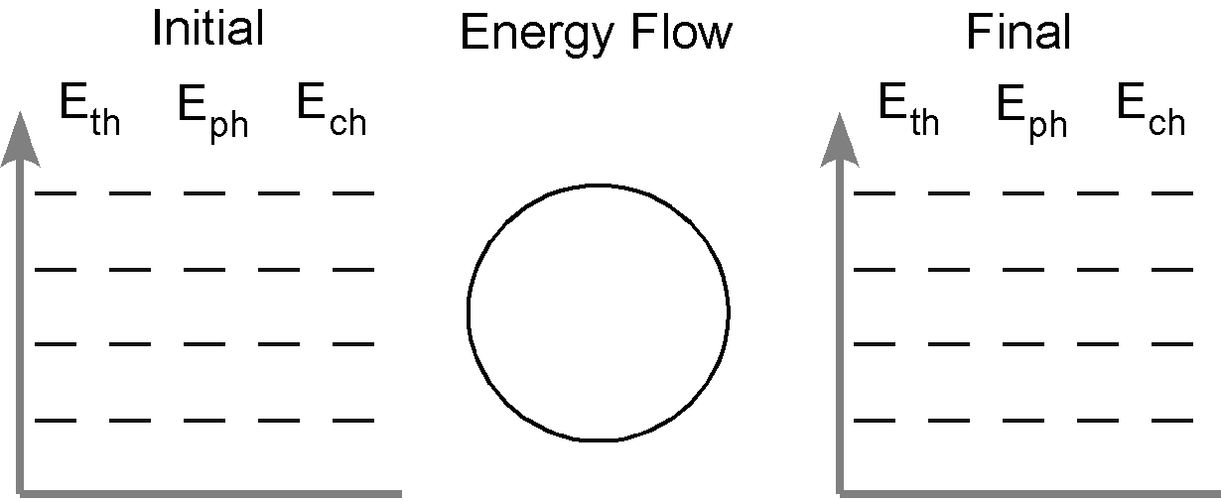

2. A can of cold soda warms as it is left on the counter.

3. A tray of water (20 ˚C) is placed in the freezer and turns into ice cubes (- 8 ˚C)

4. Where does the energy that leaves the system in #3 go? How does this energy transfer affect the room temperature in the kitchen? Do you have any experience that supports your answer?

5. One of the ice cubes described in #3 is placed in a glass of room temperature (25 ˚C) soft drink. Do separate bar charts for the ice cube and the soft drink.
Describe how the arrangement and the motion of the particles in each system change from the initial to the final state.

6. A plant sits in the sun, turning low chemical energy CO₂ into higher chemical energy C₆H₁₂O₆

7. A paperclip you put in the microwave is shooting off hundreds of sparks but gets so hot that it melts

