East.H.S. ©λ€M|5+rγ  visit http://genest.weebly.com | 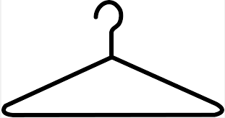 | Name_________________  Date__________________  This Friday is a tiny quiz  Thursday Nov 11 is a big Test  Friday Nov 12 there is no school for students

Here are four things you DO need to be careful about in LoL energy diagrams: |  | Here are two things you DON’T need to be careful about in LoL energy diagrams:
Mistake A The total initial, and the total final MUST agree with the number of squares of energy that entered or left the system. |  | - The amount that enters or leaves the system circle is not exact. We make that up randomly.
Mistake B The direction of the arrow must be correct. Light must COME OUT from a firecracker, not go in. Light must GO IN to a growing corn plant performing photoshythesis, not come out. |  | - The number of squares in the beginning is just some arbitrary number that we make up at random. Some people find it comfortable to always start with 4, 4, 4 in the initial box.
Mistake C If something changes from solid to liquid to gas, the Eph must increase. Going the other way, if something changes gas to liquid or liquid to solid, the Eph must decrease

Mistake D If the formula of the substance is the same before and after, the Ech CAN NOT change. A big example of this is phase changes of water. if an ice cube turns into a puddle of water, the Ech did not change, the Eph went up though.

1. A glass of 30- degree C tea is heated to 80 degrees in a microwave oven.
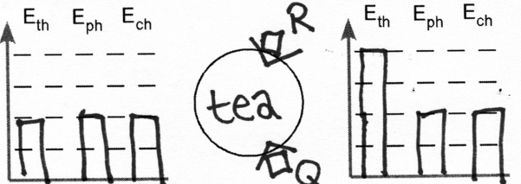 | 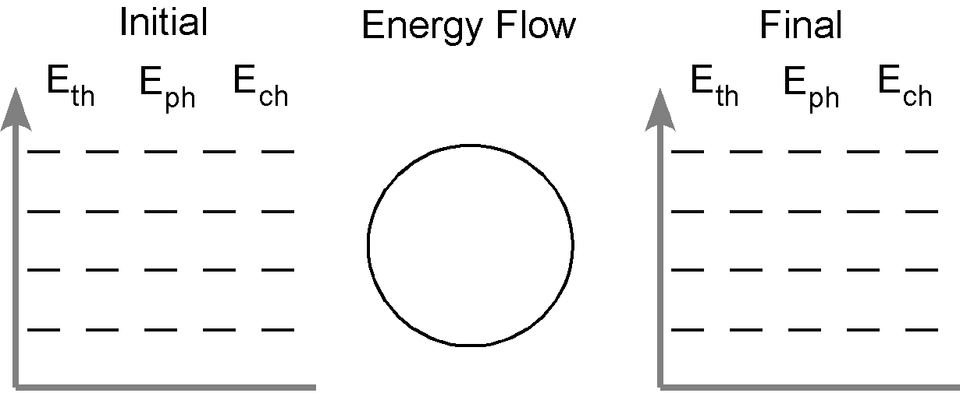
List what was wrong with the drawing on the left and redraw it better on the right.

Mistake: _________________________________________________________________

Mistake: _________________________________________________________________

2. A tray of 20 degree C water is placed in a freezer and changes to ice cubes that are negative eight degrees C
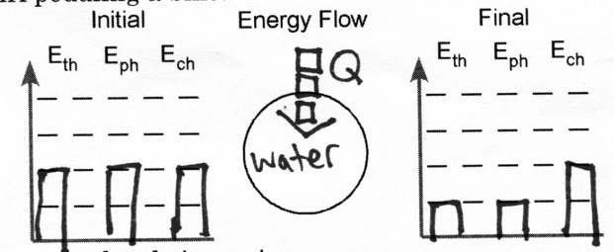
List what was wrong with the drawing on the left and redraw it better on the right.

Mistake: _________________________________________________________________

Mistake: _________________________________________________________________

3. A firecracker explodes
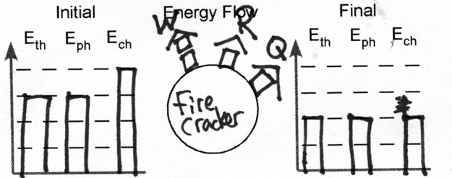
List what was wrong with the drawing on the left and redraw it better on the right.

Mistake: _________________________________________________________________

Mistake: _________________________________________________________________

4. A bike tire contains 8.38x1024 air molecules at 2.00 atm. By pumping it, you add 5.5x10²³ air molecules. What is the final pressure of the bike tire?

