Contrast particles gaining E_{th} versus gaining E_{ph}  East.H.S. ©λ€M|5+rγ  visit http://genest.weebly.com | 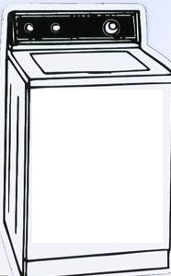 | Name_________________  Date__________________  This Friday is a tiny quiz  Thursday Nov 11 is a big Test  Friday Nov 12 there is no school for students

- Draw the energy diagram for a puff of steam (H₂O gas) changing into condensation on a soda can. | 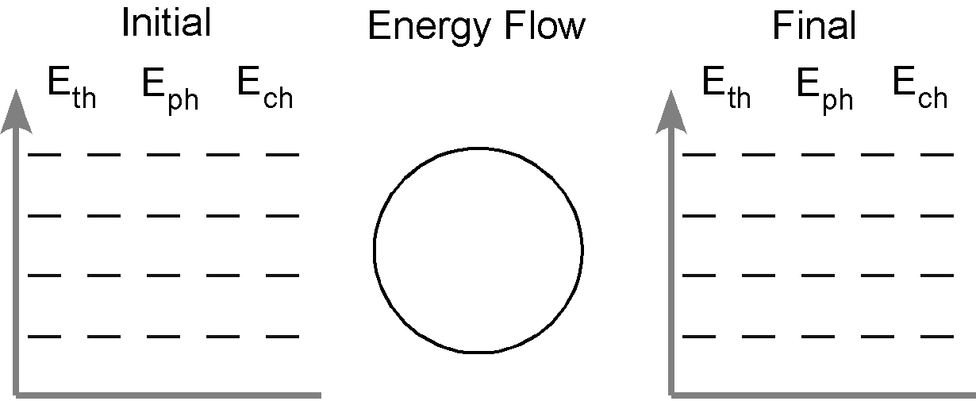

- Draw the energy diagram for you, running to catch the bus, using the calories from a granola bar you ate at lunchtime.
- Name a food that is healthy but tastes terrible: __________

- Define kinetic energy
- Define potential energy
- Decide which kind of energy was increased in each case.
Object | Type of energy that was added |  | Object | Type of energy that was added
a mousetrap has been set by pulling back the spring | □ kinetic  □ potential |  | cold tea was heated to hot tea | □ kinetic  □ potential
a book is moved from the floor up to a tabletop | □ kinetic  □ potential |  | solid iron at its m.p. was heated until it was liquid at the same temperature | □ kinetic  □ potential
When something gains E_{th} | □ kinetic  □ potential |  | When something gains E_{ph} | □ kinetic  □ potential

- Some H₂O is heated from -20°C to -°10C (note the negative signs). Check the correct box at right and then draw a particle ‘movie’ of how the H₂O particles are changing in the three squares as time goes on. |  |  |  |  | Most of the added energy is going in and being stored as  □ kinetic energy  □ potential energy
1 |  | 2 |  | 3

- Some H₂O is heated from liquid at 100°C to solid at 100°C . Check the correct box at right and then draw a particle ‘movie’ of how the H₂O particles are changing in the three squares as time goes on. |  |  |  |  | Most of the added energy is going in and being stored as  □ kinetic energy  □ potential energy
1 |  | 2 |  | 3

The ramp-shaped graph at the right is a preview of our Friday lab this week.  This graph shows the temperature of a block of titanium as it is heated from solid, to liquid, and finally to gas.  - Put little K’s all along the line of this graph if it is a time when the titanium is gaining mostly kinetic energy  - Put little P’s all along the line of this graph if it is a time when the titanium is gaining mostly potential energy  - Draw a circle around the part of the graph where you think E_{th} is increasing. Label it E_{th}  - Draw a circle around the part of the graph where you think E_{ph} is increasing. Label it E_{ph} | 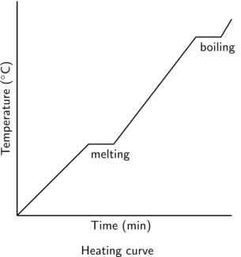

- A bike tire contains 8.38x10²⁴ air molecules at 2.00 atm. When you filled it in the morning the air was 12°C and the pressure was 3.5x10⁵Pa. By nighttime, the temperature of the tire is 0°C. What is the new pressure of the tire?

