potential energy and caloric  E.H.S. ©λ#M!$+rγ  Mr. Genest | 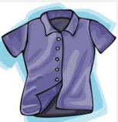 | Name_________________  Date__________________  Tutors! Adults! Help this young chemist by visiting http:genest.weebly.com with any smart phone

- During which segment is the kinetic energy increasing?  a) C to D b) D to E  - During which change is particle separation increasing  a) B to C b) C to D  - What is the melting point of the substance?  ____________  - During which segment is the E_{th} energy increasing?  a) C to D b) D to E  - During which change is E_{ph} increasing  a) B to C b) C to D  - During how many of the segments is the potential energy increasing? ______________  - During how many of the segments is the Ech increasing? ______________ | 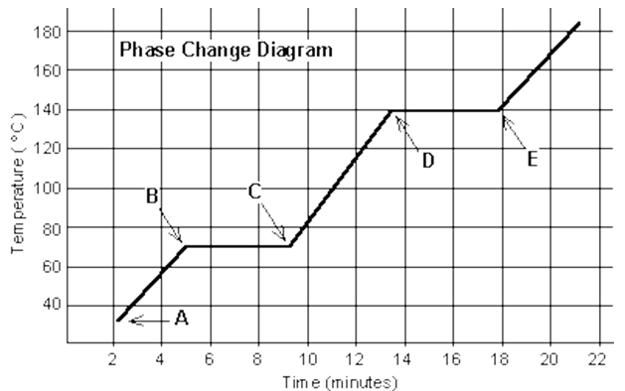

- An ice cube is placed in a glass of room temperature (25 ˚C) soft drink and completely melts. Do a bar chart for the ice cube.
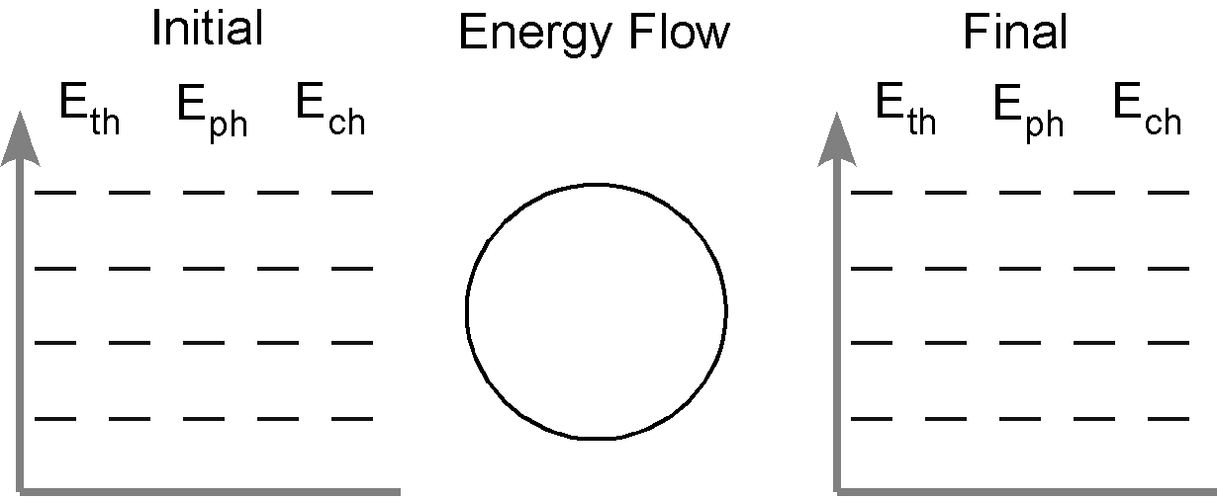

The following questions test things you learned from last Friday’s reading. If you need another copy of the Energy Reading, go to the class website for Oct. 30

- Describe what early chemists meant by caloric

- Who was the only scientist from our ‘Absolute Zero’ movie that believed in ‘Caloric’? (He even thought it was an element and he listed it along with nitrogen and oxygen as being a type of matter). ___________________________________

- We describe three storage “accounts” to understand the changes we see in chemistry. State their names and give the three letter abbreviations we use in LoL energy diagrams for them (each abbreviation starts with the letter E). | - We can transfer energy by three mechanisms. Name these and give the single letter abbreviations we use in LoL energy diagrams for them

You will always be given these numbers on tests and quizzes.
760. torr = 760. mmHg = 1.00 atm = 101.3 kPa = 101,300 pascals = 14.7 p.s.i.

- A metal tube contains Avogadro’s Number of air molecules. . After 4.0x10²² atoms escape, its pressure is 7.70x10¹¹ pascals. What was the original volume?

- Which scientist showed that heat/cold is not a substance? He did this by making water boil for hours and hours just by drilling a cannon (See the website for advice on how to get movie notes from the movie we are watching. . .)

  - Faraday
  - Celsius
  - Fahrenheit
  - Rumford

