Name_________________________________________________________________________________Hr.________
Materials:
Reprint of “Sugar, An Unusual Explosive” from ChemMatters December 2010, which we divided into two parts, both for the same day:
Section A: the first ten paragraphs
Section B: the rest of the article.
- Make your key to show what symbols you used when marking the text.
Main ideas are marked by _______________________________
Vocabulary you want to look up is marked by __________________
Things you wonder about are marked by _______________________

- With a partner create a Venn Diagram where the two circles are “sugar combustion” and “sugar explosion”.

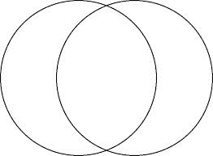

- Answer the following questions*. (DO NOT DO THIS UNTIL STEP 2 THROUGH 6 ARE COMPLETE)
- Hand in (okay to stack if too thick to staple):
  - marked up reading
  - Venn diagram
  - Answered questions
*Here are the questions for the Part B sheet:
  - What factors affect the rate of a reaction?

  - What causes the difference between a slow reaction and fast reaction of the combustion of sugar?

  - Explain what is meant by surface area, and how does it change the rate of a reaction.

  - Making a shape modified from Figure 2, sketch here a model that shows something that has the same total volume but more surface area than (a) but less than (b)

