Homework Name________________________
- In each case below, the system is UNDERLINED. Draw an Energy bar chart for each of the following situations:
  - putting the cold metal into the glass with hot water.
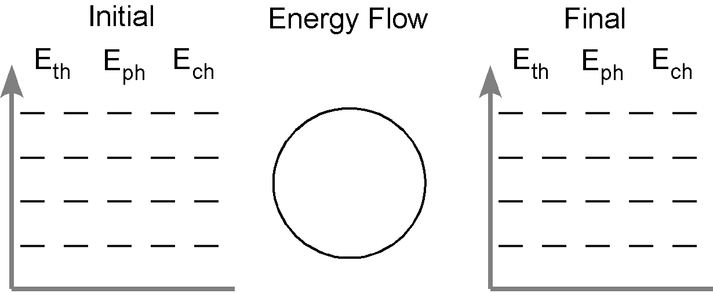

  - putting the hot metal into the white cup with cold water.

  - putting the hot metal into the white cup with cold water.

