Name_______________________________________________________________________Hr._____________
Calorimetry, First Attempt, Sloppy!
- On this graph, write the following points:
Hot metal, when the metal gets dropped into water  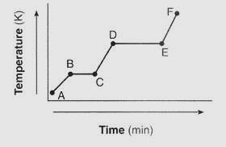  Write start and write stop to indicate what will happen to your iron when you drop it in the water | Water, when it has something hot dropped into it.  Write start and write stop to indicate what will happen to your water when you in the hot metal

- Record your lab datz for three runs if possible, each with a different amount of water
water amount (mL) | water amount (grams) | cold water temperature (°C) | warm water temperature (°C) | change of water temperature

- Only describe what happened to the underlined item.

- First trial, hot metal being dropped into cold water
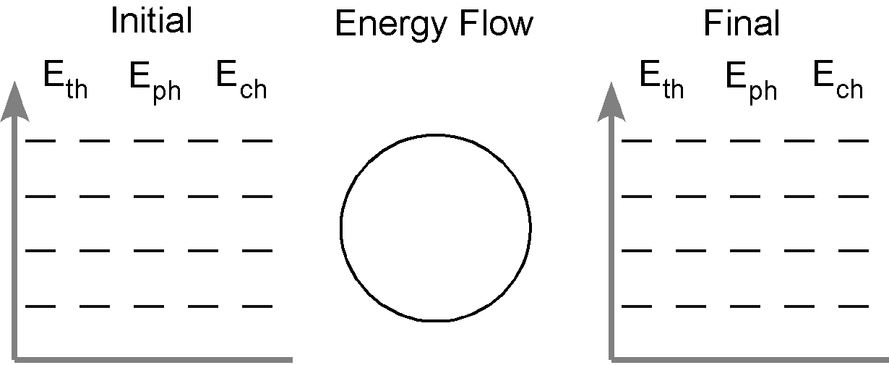
- First trial, hot metal being dropped into cold water
Important, record the water _____ grams
- Second trial, hot metal being dropped into cold water
- Second trial, hot metal being dropped into cold water
Important, record the water _____ grams
Errors [5 points!] What variables accidentally were not the same from run to run?+

1)
2)
3)
4)
5)
6)

