|  |  |  |
| --- | --- | --- |
| *compounds*  CλeMis+ry [eagenest@madison.k12.wi.us](mailto:eagenest@madison.k12.wi.us) |  | Name_____________________  Period____________________ |

|  |  |
| --- | --- |
|  | Categorize each square as either mixture, element, or compound:  A ____________________________________  B ____________________________________  C ____________________________________ |

1. Into the blanks below write the following words: *Mixtures, Mixtures of Compounds, Mixtures of Elements, All Matter, Substances, Compounds, Elements, Mixtures*

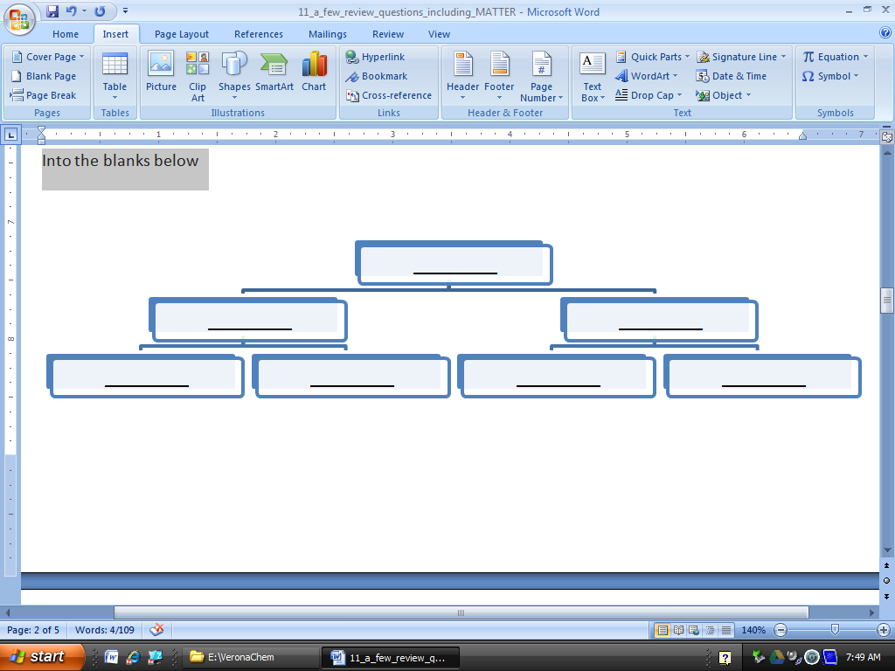

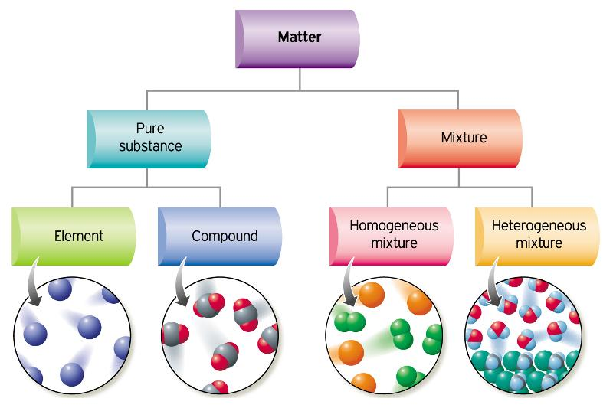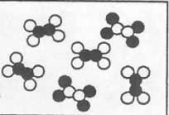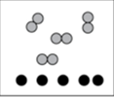

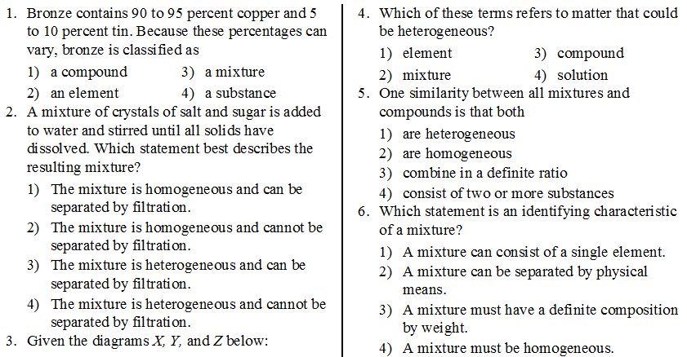

|  |  |
| --- | --- |
| 1. Under each box write *solid, gas, or liquid*.     _________________ _________________ ____________________ | Circle your choice,  These boxes *all* contain a  Element?  Compound?  Mixture? |

|  |  |
| --- | --- |
| 1. Under each box write *solid, gas, or liquid*.     _________________ _________________ ____________________ | Circle your choice,  These boxes *all* contain a  Element?  Compound?  Mixture? |

1. Identify the separation techniques pictured below. Which technique would be useful to separate a mixture of sand and salt? Of salt and water?

|  |  |
| --- | --- |
|  |  |

1. Explain why the technique at left would not be effective in separating a mixture of salt and sugar.
2. Draw particle representations for the following:

|  |  |
| --- | --- |
| A mixture of iron and sulfur | A compound of iron and sulfur |
|  |  |