Physical Changes vs Chemical Changes  East HS Chemistry  Mr.Genest | 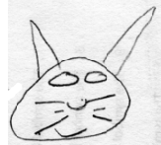 | Name__________________________  Period __________
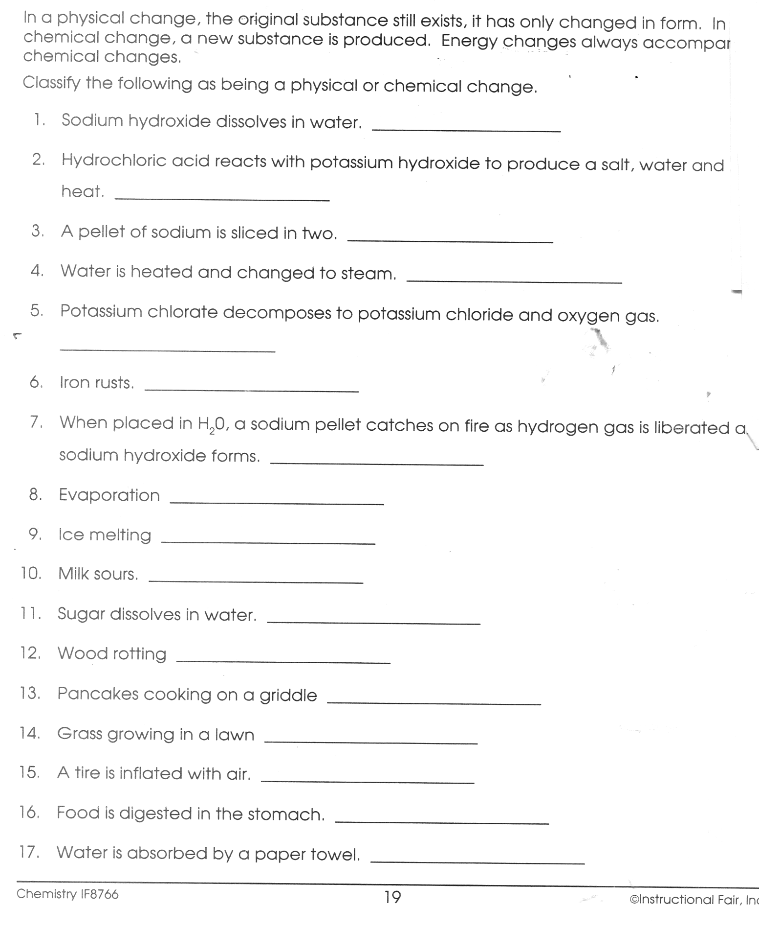

- These balloons both contain NH₃. Inside the balloon on the right draw an appropriate number of NH₃.molecules.
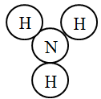
5 liter balloon | 10 liter balloon

.
- Consider the four containers below.
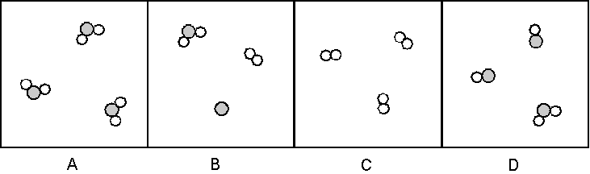
a. Which of these are mixtures? pure substances?

b. Which contain only compounds? only elements

- Consider the four containers below.
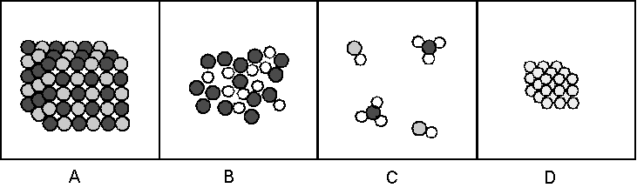
a. Which of these are mixtures? pure substances?

b. Which contain only compounds? only elements

- Consider the four containers below.
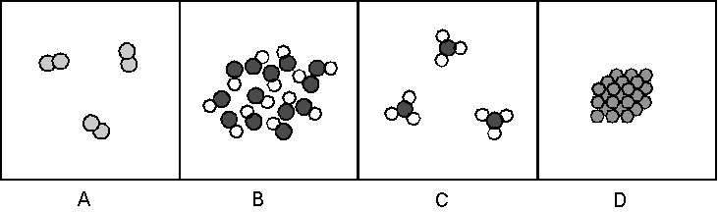
a. Which of these are mixtures? pure substances?

b. Which contain only compounds? only elements

- Which of the containers in #21 contain a gas? a liquid a solid

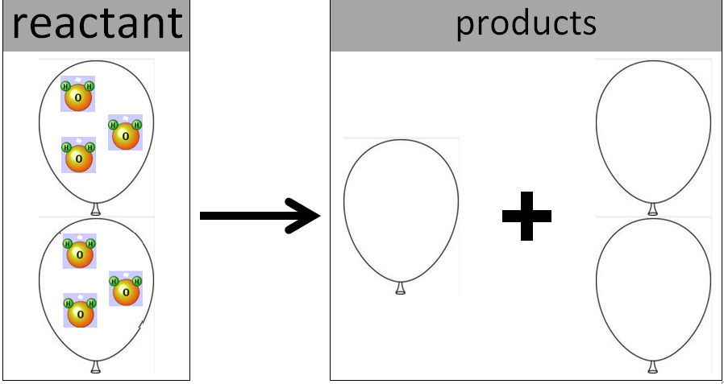
- A chemist took two balloons full of gas. She set them on fire. They created two different products. Product A is a substance that filled one balloon. Product B is a substance that filled two balloons. Draw molecules inside the three balloons showing what she created.
Hints:
- Avogadro’s Principle: Equal sized boxes have the same number of gas molecules.
- The Law of Conservation of Mass: Any atoms that exist before the arrow must be the same as the number of atoms after the arrow.
- Assume all boxes are the same size.

