Using Avogadro’s Principle to Draw Compound formulas  CλeMis+ry: http://genest.weebly.com  Stop in for help every day at lunch and Tues, Weds., &Thurs after school! |  | Name_____________  Period_____________

- State Avogadro’s Principle: _________________________________________
_______________________________________________________________________
________________________________________________________________________

- Represent molecules of hydrogen and oxygen in the containers below. React these molecules to form water molecules, leaving no leftover gas.

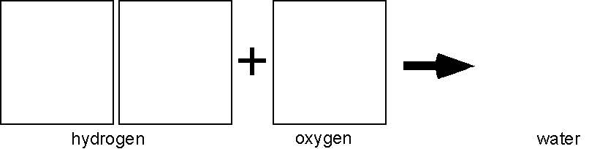
What do the H, O, and 2 in the chemical formula tell us about the composition of water?

________________________________________________________________________

- In like manner, represent particle diagrams that account for the fact that one volume of hydrogen combines with one volume of chlorine to form hydrogen chloride.

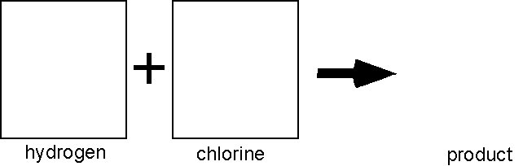

What do you suppose is the formula of hydrogen chloride? ________

- Represent the reaction in which one volume of nitrogen gas reacts with three volumes of hydrogen gas to form ammonia.

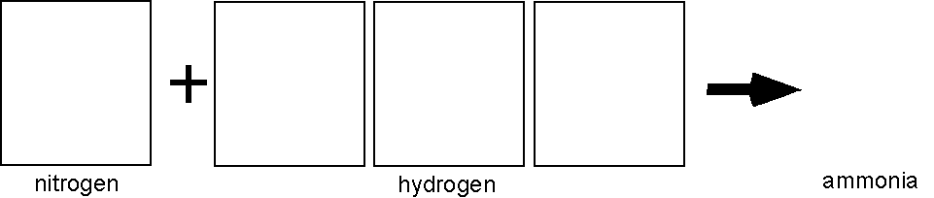
What is the formula for ammonia? ____________

Part 2
Chemists occasionally found that one volume of gas A reacted with one volume of gas B to produce two volumes of gaseous product. Early chemists like Gay-Lussac, were unable to account for this behavior of gases. Avogadro’s key contribution was that he reasoned that the molecules of some gaseous elements must contain two atoms.

- Consider the reaction between hydrogen and chlorine. Two volumes of hydrogen chloride are formed. Sketch particle diagrams consistent with Avogadro’s Hypothesis to represent this reaction. Explain why hydrogen and chlorine molecules that have only one atom each cannot account for the observed behavior.

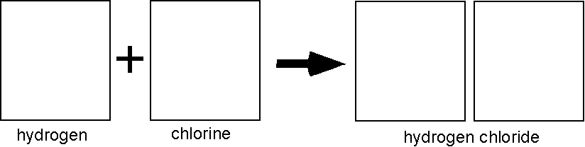

- When two volumes of hydrogen gas react with one volume of oxygen gas, two volumes of gaseous water are formed. Modify the diagram you made for #2 to represent molecules of hydrogen, oxygen and water in this reaction.

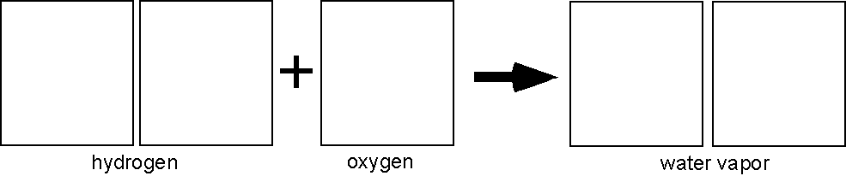

Explain why molecules of oxygen must have an even number of atoms.

_______________________________________________________________________
________________________________________________________________________

- Two volumes of nitric oxide react with one volume of oxygen gas to form two volumes of a reddish-brown gas. Deduce the formula of this gas and sketch particle representations of its molecules.

