Dalton’s Law  CλeMis+ry: http://genest.weebly.com  Stop in for help every day at lunch and Tues &Thurs after school! |  | Name_____________  Period_____________

This is due at the bell. Be sure to show all mathematical work. Half off if turned in tomorrow.

- If a small crumb of aspirin has a mass of 0.5405 grams and contains 0.3243g of carbon, 0.0242g of hydrogen, and 0.192g of oxygen, calculate the following:  - A fraction that shows the ratio of the mass of carbon to the total mass of the sample  - A fraction that shows the ratio of the mass of oxygen to the total mass of the sample  - Using your ratio from (a) calculate the percent of aspirin that is carbon by mass.  - Using your ratio from (b) calculate the percent of aspirin that is oxygen by mass. | - Table sugar is a compound known as sucrose. Sucrose is composed of the elements carbon, hydrogen, and oxygen. Analysis of a 20.0 g of sucrose from a bag of sugar finds that the sugar is composed of 8.44 g of carbon, 1.30 g of hydrogen, and 10.26 g of oxygen.  - Express, as fractions, the ratio of the mass of these three elements to the total mass of the sample. The first has been done for you as an example.  - Using these ratios, calculate the percent composition by mass of each element in the compound.

- State Proust’s Law:  _______________________________________  _______________________________________  _______________________________________  _______________________________________  _______________________________________  - A chemical analysis is performed on a 500.0 g sample of the sugar isolated from a sample of pure sugar cane. Analysis shows this sample contains 211.0 g of carbon, 32.5 g of hydrogen, and 256.5 g of oxygen.  - Determine the percent composition by mass of each element in the sugar cane sample.  - Based on your previous calculation, could the sugar in this sample be sucrose? Justify your conclusion. | - A similar chemical analysis is performed on a 200.0g sample of the sugar found in corn syrup. This sample contains 80.0g of carbon, 13.3 g of hydrogen and 106.7 g of oxygen.  - Determine the percent composition by mass of each element in the sugar cane sample.  - Could the sugar in corn syrup be sucrose? Justify your conclusion.

- A 1.0 g sample of hydrogen reacts completely with 19.0 g of fluorine to form a compound of hydrogen and fluorine.  - What is the percent by mass of each element in the compound?  - What mass of hydrogen would be present in a 50 g sample of this compound? (Remember, show work.)  - A compound contains elements X and Y. Four samples with different masses and the masses of X and Y in each sample were plotted on a graph shown in the figure below. The samples are labeled I, II, III, and IV.  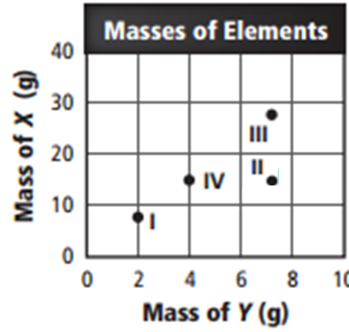  Are any of the samples the same substance? Which? (Support your answer by showing your math.) | - Two compounds of hydrogen and oxygen are tested. Compound I contains 15.0 g of hydrogen and 120.0 g of oxygen. Compound II contains 2.0 g of hydrogen and 32.0 g of oxygen.  - Determine the ratio of the mass of oxygen to the mass of hydrogen in each of the compounds.  - Are these the same substance?  - how much oxygen would be in a 400. g sample of Compound I?  - Use your algebra skills to figure out What would be the total mass of a sample of Substance II if it contained 10.00 grams of hydrogen?

