Ratios of Elements  CλeMis+ry: http://genest.weebly.com  Stop in for help every day at lunch and Tues &Thurs after school! |  | Name_____________  Period_____________

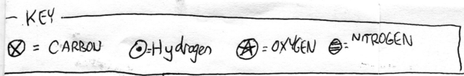
- In the next several problems, if given a formula draw the molecules, if given a cartoon, write the formula. The arbitrary symbols above are just made up by me and are not to be memorized.

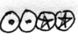 |  | 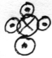 |  | 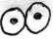
Symbols: _______________ |  | Symbols: _______________ |  | Symbols: _____________

Symbols: 3H₂O |  | Symbols: C₃H₄ |  | Symbols : 3 NH₃

- It is often convenient to cartoon molecules as circles with a letter to show what element each atom is.  Write the full name, spelling counts, of the seven elements that exist as diatomic molecules when they are pure and by themselves:  ____________________________________________________________________________  ____________________________________________________________________________ | 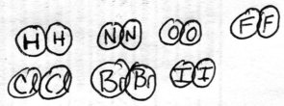

- When bromine is by itself, with no other elements, how many atoms of bromine will be in that molecule ? ( 1 / 2 / variable )
- When bromine is in a compound, with one or more other elements, how many atoms of bromine will be in that molecule ? ( 1 / 2 / variable )
- When hydrogen is in a compound, with one or more other elements, how many atoms of hydrogen will be in that molecule ? ( 1 / 2 / variable )
- When oxygen is by itself, with no other elements, how many atoms of oxygen will be in that molecule ? ( 1 / 2 / variable )

- Use any drawing style you wish to show the correct number of molecules before and after the reaction arrow.
Remember the rules: (a) same size boxes should have the same number of molecules. (b) atoms cannot appear or disappear

 | +
4F₂ |  | 4Br₂ |  | 4FBr 4FBr

 |  |  | +
two boxes with 3 diatomic molecules of hydrogen each |  |  |  | one box with some diatomic oxygen molecules (how many if it’s the same size box?) |  | only water molecules. think about what formula and how many should be in each box
- When water is heated over a fire, bubbles form. This is a (physical chemical) change.
We know this because the the bubbles are ( still the same substance / a new substance with new properties )

- Draw a particle picture of boiling water. Draw a bunch of liquid H₂O particles outside the bubble and some gas H₂O particles inside the bubble.
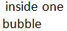
- When water is heated over a fire, bubbles form. This is a (physical chemical) change.
We know this because the the bubbles are ( still the same substance / a new substance with new properties )

- Draw a particle picture of water that is undergoing electrolysis. Draw a bunch of liquid H₂O particles outside the bubbles. There should be pure oxygen and pure hydrogen somewhere in these bubbles. (Remember to draw diatomic molecules). Challenge: The three bubbles are all the same size. What pure element should you draw in the third bubble?

