Ratios of Elements  CλeMis+ry: http://genest.weebly.com  Stop in for help every day at lunch and Tues &Thurs after school! |  | Name_____________  Period_____________

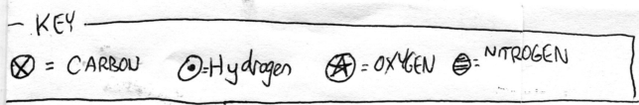
Directions: The arbitrary symbols at left are just made up by me and are not to be memorized. In the next several problems, if given a formula draw the molecules, if given a cartoon, write the formula.

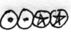 |  | 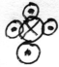 |  | 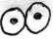
Symbols: _______________ |  | Symbols: _______________ |  | Symbols: _____________

Symbols: 3H₂O |  | Symbols: C₃H₄ |  | Symbols : 3 NH₃

It is often convenient to cartoon molecules as circles with a letter to show what element each atom is.  You should memorize that the elements hydrogen, nitrogen, oxygen, fluorine, chlorine, bromine, and iodine exist as diatomic molecules when not combined with another element. These diatomic molecules could be shown as in the drawings to the right. | 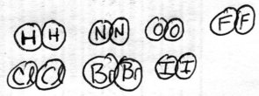

Use any drawing style you wish to show the correct number of molecules before and after the reaction arrow.
Remember the rules: (a) same size boxes should have the same number of molecules. (b) atoms cannot appear or disappear

 | +
4F₂ |  | 4Br₂ |  | 4HBr + 4HBr

 |  |  | +
two boxes with 3 diatomic molecules of hydrogen each |  |  |  | one box with some diatomic oxygen molecules (how many if it’s the same size box?) |  | only water molecules. think about what formula and how many should be in each box

- If the formula of ethane is C₂H₆, and you have 30 molecules of ethane, how many atoms of hydrogen do you have?  - If the reaction of hydrogen to produce water is written 2H₂ + O₂ 2HO, and you do a reaction where 56,000 oxygen molecules react, how many hydrogen molcecules will react?  - If the formula of ethane is C₂H₆, and you have 455 atoms of carbon in some ethane, how many atoms of hydrogen do you have?  - If the reaction of hydrogen to produce water is written 2H₂ + O₂ 2HO, and you do a reaction where 566 oxygen molecules react, how many hydrogen molecules will react?  - If the reaction of hydrogen to produce water is written 2H₂ + O₂ 2HO, and you do a reaction where 1234 molecules of water form, how many hydrogen molecules reacted? | - If the reaction of hydrogen to produce water is written 2H₂ + O₂ 2HO, and you do a reaction where 5.6x10⁵ hydrogen molecules react, how many hydrogen molecules will react?  - If the reaction of hydrogen to produce water is written 2H₂ + O₂ 2HO, and you do a reaction where 4.33x10²⁴ oxygen molecules react, how many hydrogen molecules will react?  - Two compounds of hydrogen and oxygen are tested. Compound I contains 15.0 g of hydrogen and 120.0 g of oxygen. Compound II contains 2.0 g of hydrogen and 32.0 g of oxygen.  - Determine the ratio of the mass of oxygen to the mass of hydrogen in each of the compounds.  - Are these the same substance?  - how much oxygen would be in a 400. g sample of Compound I? (Set this up like a ‘lonely number’ problem, with a ratio in the set-up.)
- In the previous problem, what would be the total mass of a sample of Substance II if it contained 10.00 grams of hydrogen? (Set this up like a ‘lonely number’ problem, with a ratio in the set-up.)

